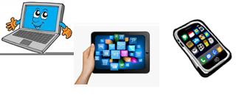
Home Schooling 10
REVISION
TODAY WE ARE CHECKING WHAT WE KNOW ABOUT:
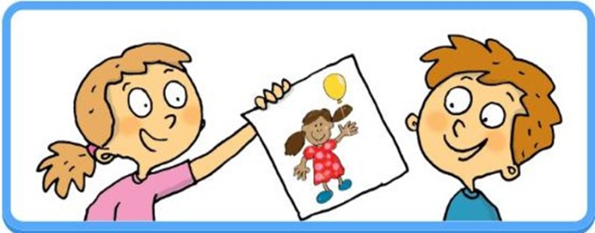

HIS/HER

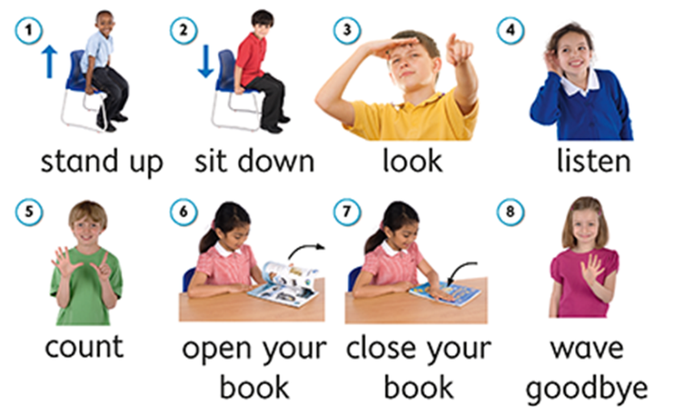

ACTIONS

NOW CLICK AND WORK ONLINE:
https://forms.gle/zz9RkSaXJGZFpbgL9
PLEASE PRESS “SUBMIT/SEND” AT THE END OF YOUR ONLINE WORK
POR FAVOR PRESIONAR “ENVIAR” AL FINAL DEL TRABAJO EN LINEA

