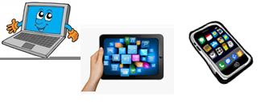
Home Schooling 13

TODAY WE ARE LEARNING SOME QUESTIONS AND ANSWERS
FOR EXAMPLE:
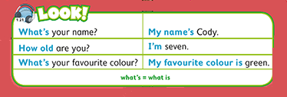
LISTEN AND SAY.

Press ctrl and click to listen to the audio file:
https://bit.ly/3aguSVe
Now, LISTEN AND REPEAT.
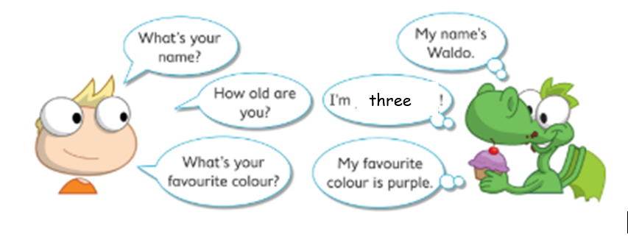
NOW CLICK AND WORK ONLINE:
https://forms.gle/4HN8gxXwq9y7rqGZA
PLEASE PRESS “SUBMIT/SEND” AT THE END OF YOUR ONLINE WORK
POR FAVOR PRESIONAR “ENVIAR” AL FINAL DEL TRABAJO EN LINEA

