Home Schooling 18

TODAY WE’RE LEARNING TO ASK AND ANSWER QUESTIONS ABOUT COLOURS!
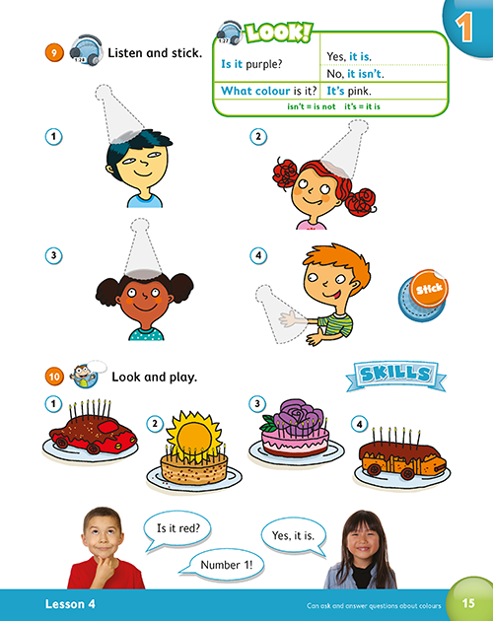

Press ctrl and click to listen to the audio file:
https://bit.ly/2zkeCFX
NOW, LISTEN AND REPEAT. 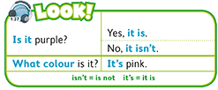
MORE EXAMPLES:
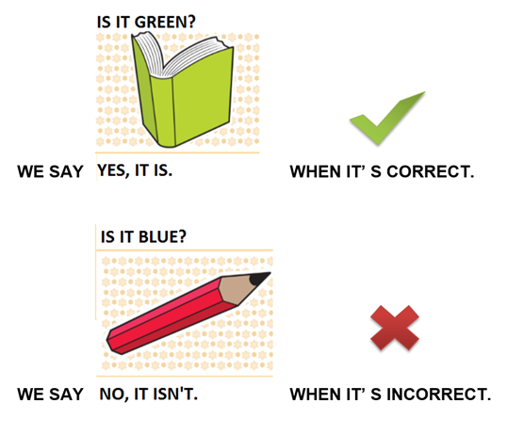

CLICK AND WORK ONLINE:
https://forms.gle/6jiTWUKcamwUQK2j9
PLEASE PRESS “SUBMIT/SEND” AT THE END OF YOUR ONLINE WORK
POR FAVOR PRESIONAR “ENVIAR” AL FINAL DEL TRABAJO EN LINEA

