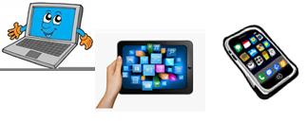
Home Schooling 24
TODAY WE’RE STARTING UNIT 2!
WE'RE LEARNING WORDS FOR CLASSROOM OBJECTS.
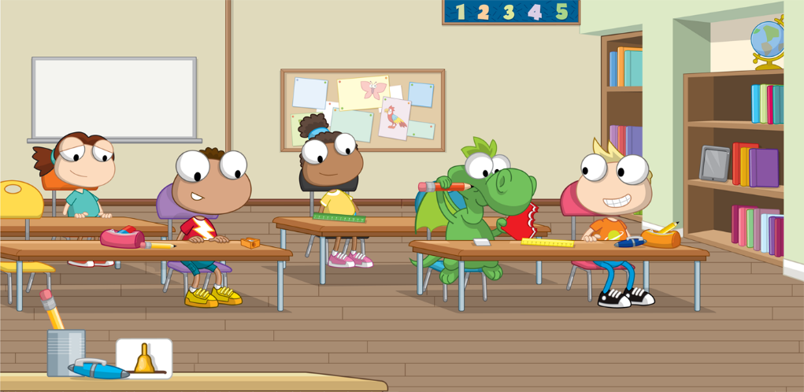
CTRL+CLICK HERE:
https://bit.ly/2ZPdZPO

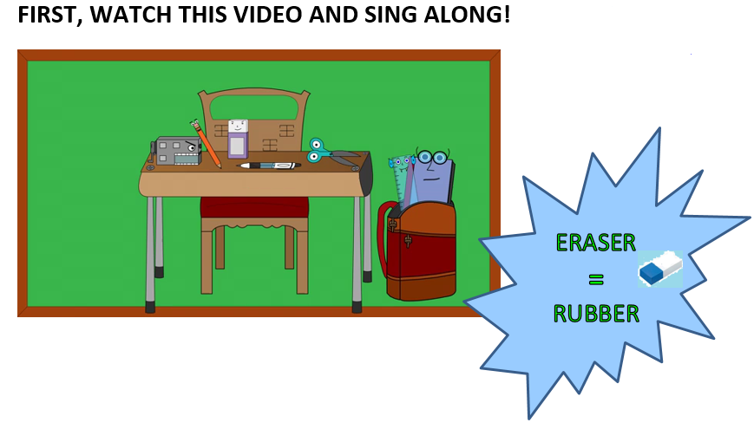

WE ARE WORKING ON PAGES 22 AND 23.
Press ctrl and click to listen to the audio file:
https://bit.ly/3ddzsFX
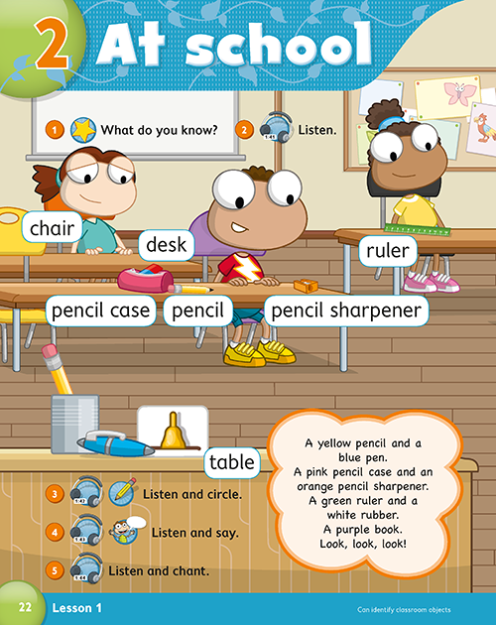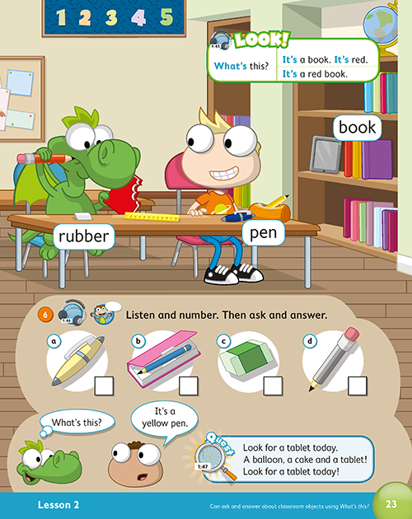
NOW, LISTEN AND SING!
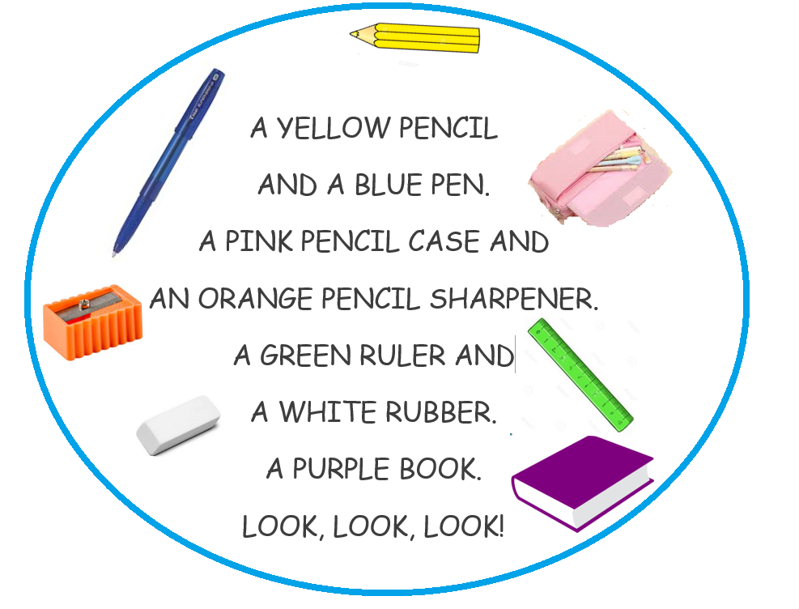
NOW GO ONLINE

CTRL+ CLICK AND WORK ONLINE:
https://forms.gle/vGghV8AeuybprUjn8
PLEASE PRESS “SUBMIT/SEND” AT THE END OF YOUR ONLINE WORK
POR FAVOR PRESIONAR “ENVIAR” AL FINAL DEL TRABAJO EN LINEA

