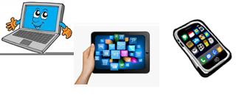
Home Schooling 25

TODAY WE’RE LEARNING QUESTIONS WITH
“WHAT’S THIS?”:
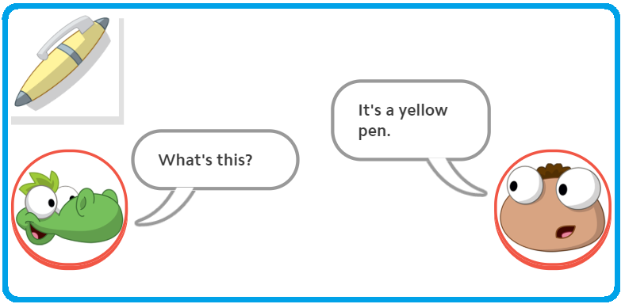

Press ctrl and click to listen to the audio file:
https://bit.ly/2AlAXDq
FIRST, LISTEN AND REPEAT:

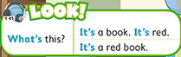

NOW GO ONLINE
NOW CLICK AND WORK ONLINE:
https://forms.gle/TtYNo9BSd8oMbmKNA
PLEASE PRESS “SUBMIT/SEND” AT THE END OF YOUR ONLINE WORK
POR FAVOR PRESIONAR “ENVIAR” AL FINAL DEL TRABAJO EN LINEA

