Home Schooling 30
TODAY WE’RE LOOKING AT DIFFERENT SCHOOLS
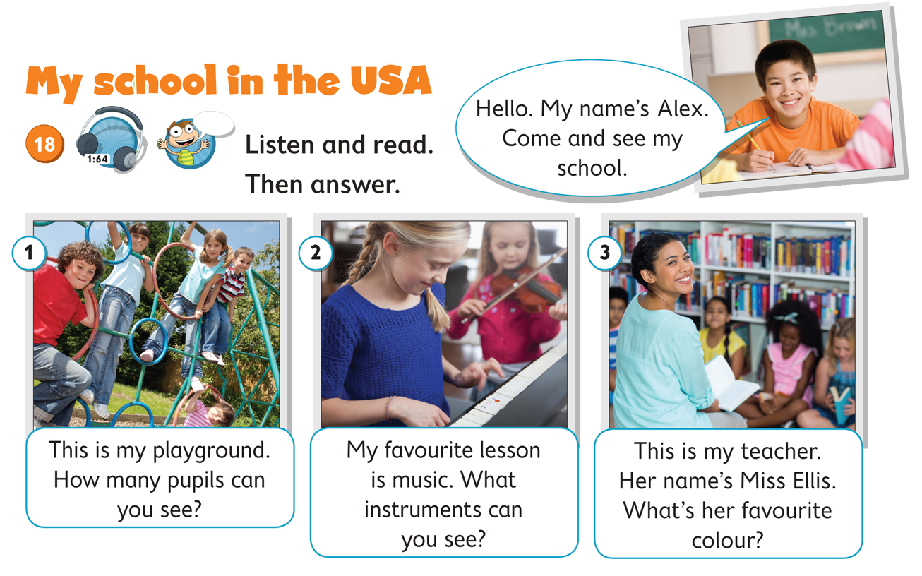
NOW GO ONLINE

CTRL+CLICK AND WORK ONLINE:
https://forms.gle/XCHfhmfHrMxyuPkT8
PLEASE PRESS “SUBMIT/SEND” AT THE END OF YOUR ONLINE WORK
POR FAVOR PRESIONAR “ENVIAR” AL FINAL DEL TRABAJO EN LINEA

WHAT IS YOUR SCHOOL LIKE?

PROJECT

