Home Schooling 31

TODAY WE’RE REVIEWING UNITS 1 AND 2:
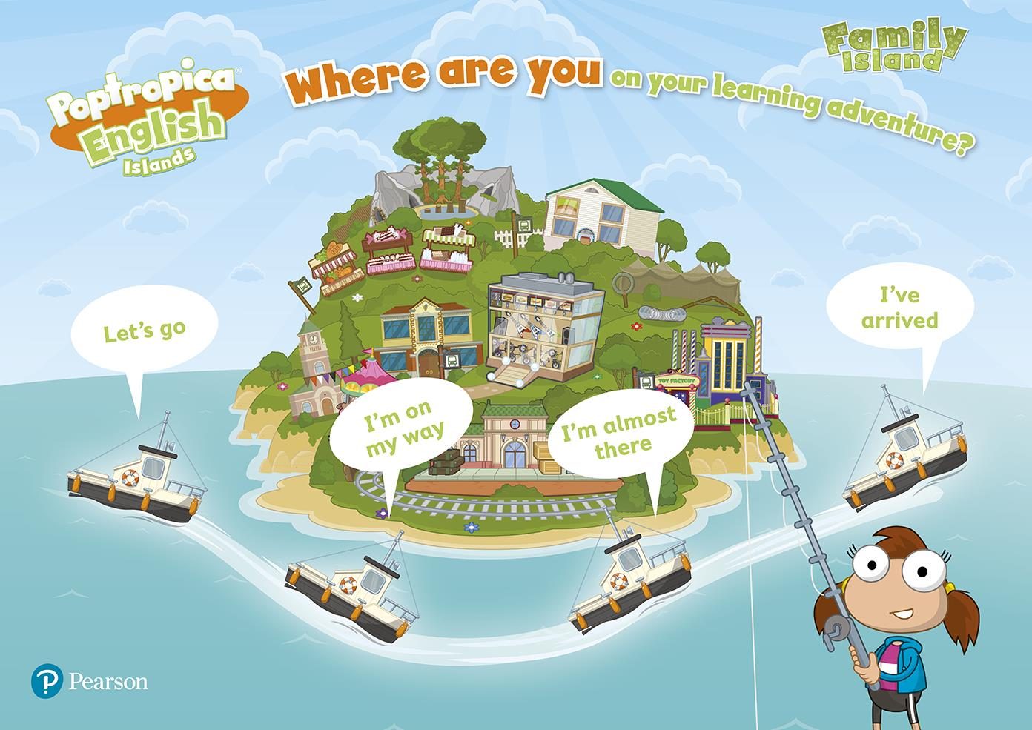
NOW GO ONLINE

CTRL+CLICK AND WORK ONLINE:
https://forms.gle/c6pLBQkmjvgxH2om7
PLEASE PRESS “SUBMIT/SEND” AT THE END OF YOUR ONLINE WORK
POR FAVOR PRESIONAR “ENVIAR” AL FINAL DEL TRABAJO EN LINEA

