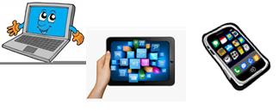
Home Schooling 6

TODAY WE ARE LEARNING HOW TO USE HIS AND HER
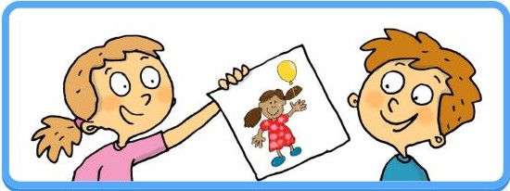

WE USE HIS TO SAY THAT SOMETHING BELONGS TO A BOY.
FOR EXAMPLE:
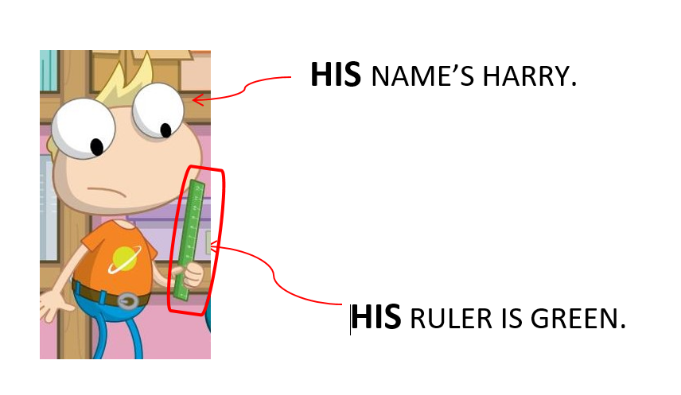
THE RULER BELONGS TO HARRY.
WE USE HER TO SAY THAT SOMETHING BELONGS TO A GIRL.
FOR EXAMPLE:
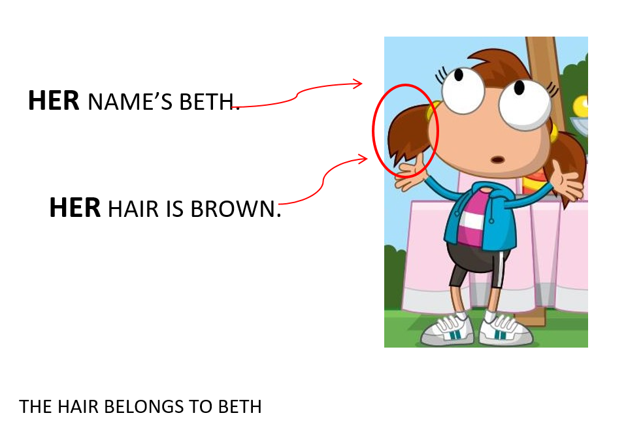

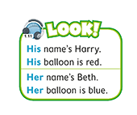
PRESS CTRL AND CLICK HERE: https://bit.ly/2wR89l2 TO LISTEN AND SAY

NOW CLICK AND WORK ONLINE:
https://forms.gle/JcjfbUyMLRfiPtC97
PLEASE PRESS “SUBMIT/SEND” AT THE END OF YOUR ONLINE WORK
POR FAVOR PRESIONAR “ENVIAR” AL FINAL DEL TRABAJO EN LINEA

