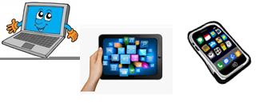
Home Schooling 7

TODAY WE ARE LEARNING CLASSROOM ACTIONS
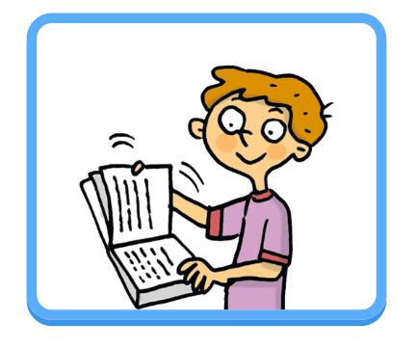
Press ctrl and click https://bit.ly/2X6wsWE
to listen to the audio file
LISTEN, LOOK AND DO THE ACTIONS

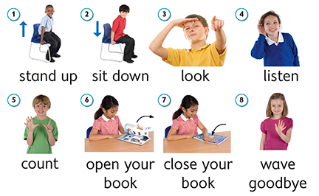

NOW CLICK AND WORK ONLINE:
https://forms.gle/iMUsrHUmCJkRqdSv9
PLEASE PRESS “SUBMIT/SEND” AT THE END OF YOUR ONLINE WORK
POR FAVOR PRESIONAR “ENVIAR” AL FINAL DEL TRABAJO EN LINEA

