Home Schooling 8

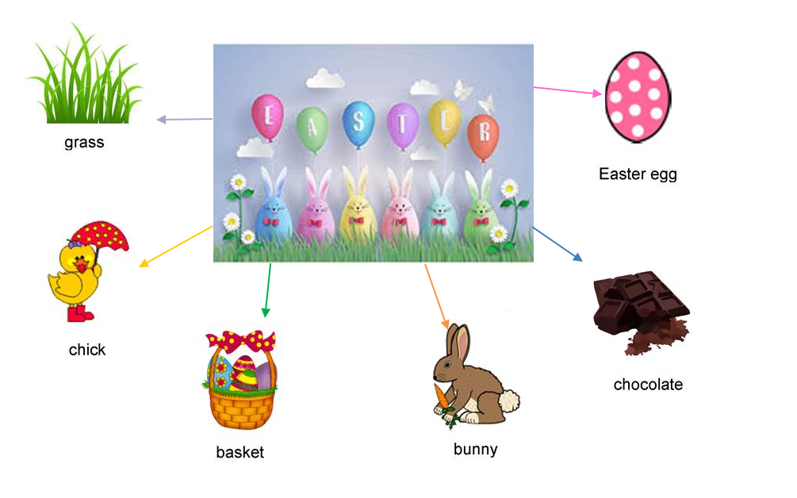

NOW CLICK AND WORK ONLINE:
https://bit.ly/2UHZPwI
PLEASE PRESS “SUBMIT/SEND” AT THE END OF YOUR ONLINE WORK
POR FAVOR PRESIONAR “ENVIAR” AL FINAL DEL TRABAJO EN LINEA

