Home Schooling 9
REVISION
TODAY WE ARE CHECKING WHAT WE KNOW ABOUT:
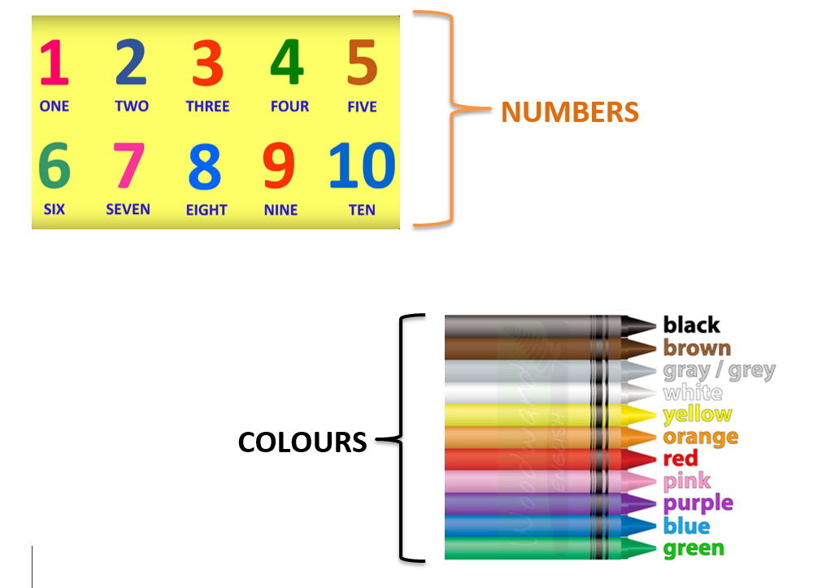

NOW CLICK AND WORK ONLINE:
https://forms.gle/aLJXFTeYjLTQ1HtC6
PLEASE PRESS “SUBMIT/SEND” AT THE END OF YOUR ONLINE WORK
POR FAVOR PRESIONAR “ENVIAR” AL FINAL DEL TRABAJO EN LINEA

