Home Schooling 14

TODAY WE ARE PRACTICING ACTIONS!
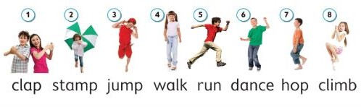

NOW CLICK AND WORK ONLINE:
https://forms.gle/ywUt8iwSDXVscyij7

PLEASE PRESS “SUBMIT/SEND” AT THE END OF YOUR ONLINE WORK
POR FAVOR PRESIONAR “ENVIAR” AL FINAL DEL TRABAJO EN LINEA

