Home Schooling 15
TODAY WE ARE PRACTICING ACTIONS!

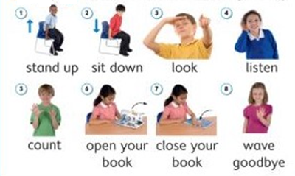

CLICK AND WORK ONLINE:
https://forms.gle/Z4HmZTmrnYqmmjqP6
PLEASE PRESS “SUBMIT/SEND” AT THE END OF YOUR ONLINE WORK
POR FAVOR PRESIONAR “ENVIAR” AL FINAL DEL TRABAJO EN LINEA

