Home Schooling 16

TODAY WE ARE PRACTISING THE QUESTION…
WHAT’S YOUR NAME?

WE’RE ALSO PRACTICING HIS AND HER

REMEMBER:

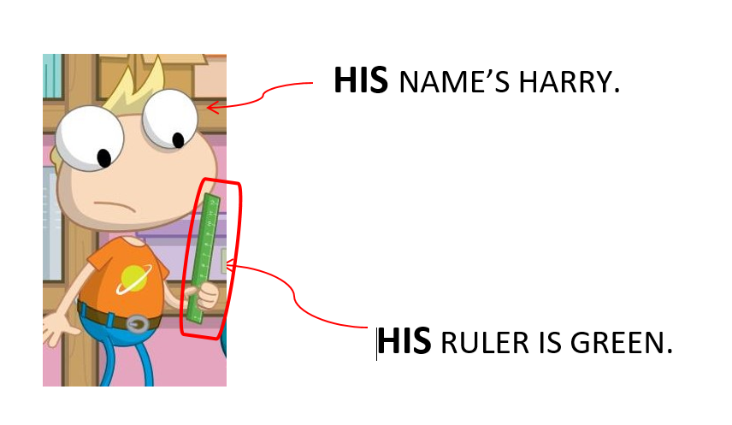
WE USE HIS FOR BOYS.

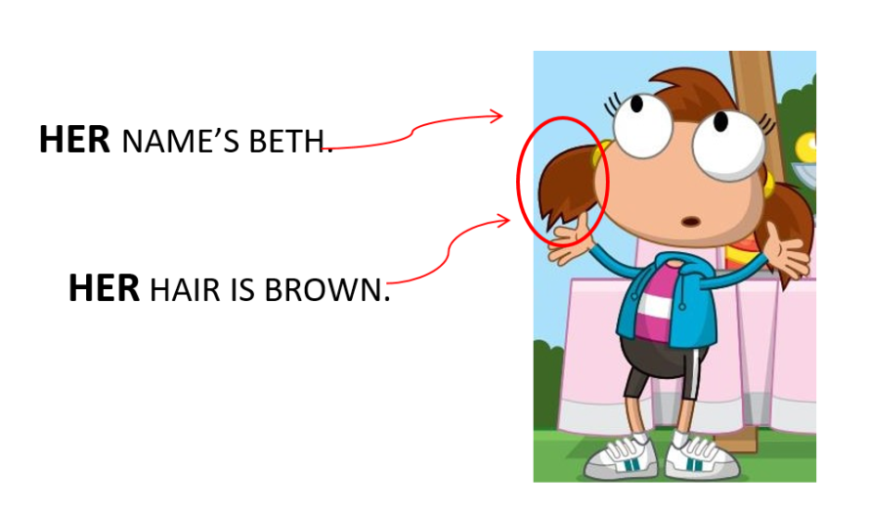
WE USE HER FOR GIRLS.

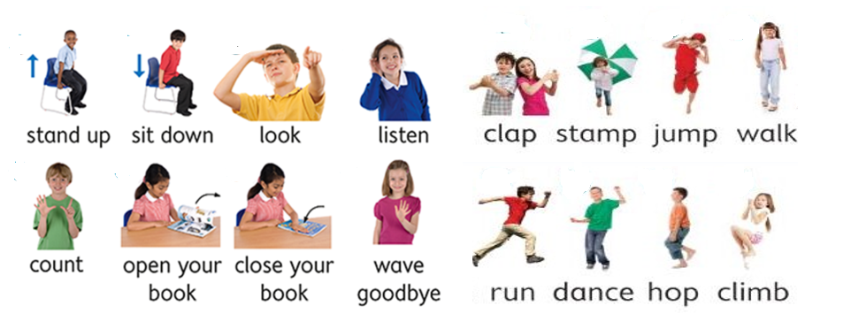
LASTLY, WE’RE PRACTICING SOME ACTIONS!

NOW GO ONLINE

NOW CTRL +CLICK AND WORK ONLINE:
https://forms.gle/8UTcrvHu6X7T3i5E6
PLEASE PRESS “SUBMIT/SEND” AT THE END OF YOUR ONLINE WORK
POR FAVOR PRESIONAR “ENVIAR” AL FINAL DEL TRABAJO EN LINEA

