Home Schooling 17

TODAY WE ARE PRACTICING THE QUESTIONS…

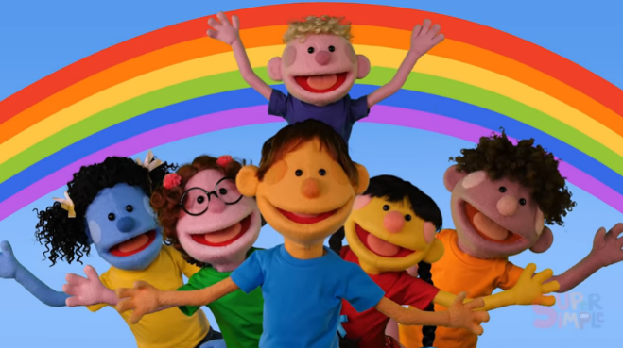
WHAT’S YOUR FAVOURITE COLOUR?

AND
HOW OLD ARE YOU?

Press ctrl and click to listen to the audio file:
https://bit.ly/2WkQTNB
LET’S REMEMBER: LISTEN AND REPEAT.
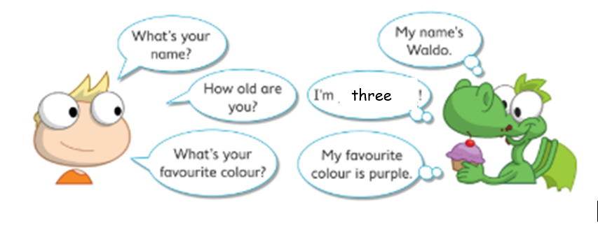

WE’RE ALSO REVIEWING THE COLOURS!

NOW GO ONLINE

NOW CLICK AND WORK ONLINE:
https://forms.gle/S7Vd7hNpxkP6gR4S6
PLEASE PRESS “SUBMIT/SEND” AT THE END OF YOUR ONLINE WORK
POR FAVOR PRESIONAR “ENVIAR” AL FINAL DEL TRABAJO EN LINEA

