Home Schooling 20

TODAY WE’RE TALKING ABOUT NATURE
Press ctrl and click to listen to the audio file:
https://bit.ly/2LLG7LD

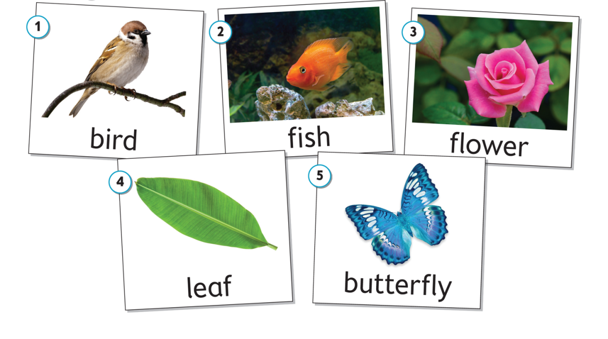
LISTEN AND POINT. THEN, REPEAT:

FOR EXAMPLE:
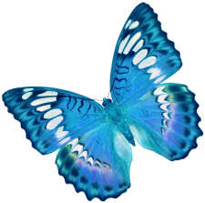

WHAT IS IT?

IT’S A BUTTERFLY.

NOW CLICK AND WORK ONLINE:
https://forms.gle/tuhMVuKau8KcyNzm9
PLEASE PRESS “SUBMIT/SEND” AT THE END OF YOUR ONLINE WORK
POR FAVOR PRESIONAR “ENVIAR” AL FINAL DEL TRABAJO EN LINEA

