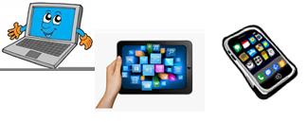
Home Schooling 21
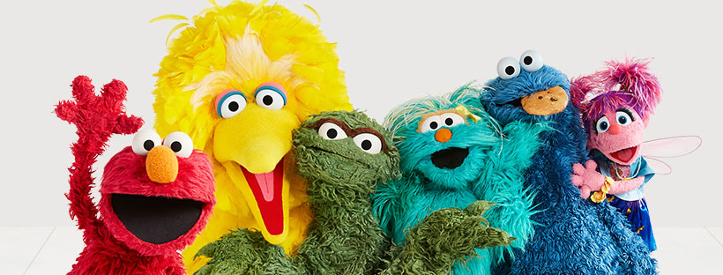

TODAY WE’RE PRACTICING THE ALPHABET
WATCH THE VIDEO AND SING
Press ctrl and click to watch the video:
https://youtu.be/6Rb-iOP2M2w

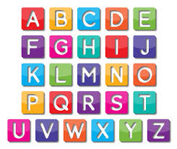
Press ctrl and click to listen to the audio file:
https://bit.ly/2z71vIa
AND SOME
LISTEN TO THE SOUNDS!
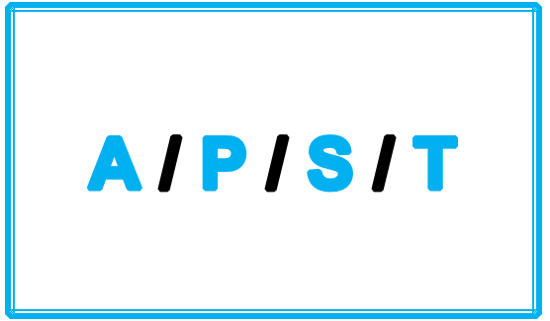
NOW CLICK AND WORK ONLINE:
https://forms.gle/ByJkFfURksU1FPeBA
PLEASE PRESS “SUBMIT/SEND” AT THE END OF YOUR ONLINE WORK
POR FAVOR PRESIONAR “ENVIAR” AL FINAL DEL TRABAJO EN LINEA

