Home Schooling 22
TODAY WE’RE TALKING ABOUT BIRTHDAY PARTIES!
LISTEN AND REPEAT:
Press ctrl and click to listen to the audio file:
https://bit.ly/3bXP5zN

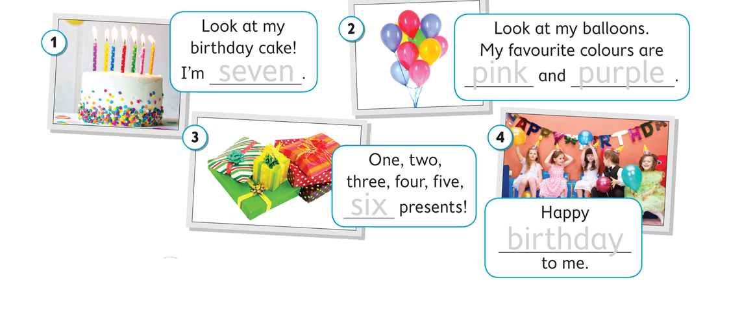
NOW GO ONLINE
NOW CLICK AND WORK ONLINE:
https://forms.gle/bD2Cmnozu4TUNkk67
PLEASE PRESS “SUBMIT/SEND” AT THE END OF YOUR ONLINE WORK
POR FAVOR PRESIONAR “ENVIAR” AL FINAL DEL TRABAJO EN LINEA
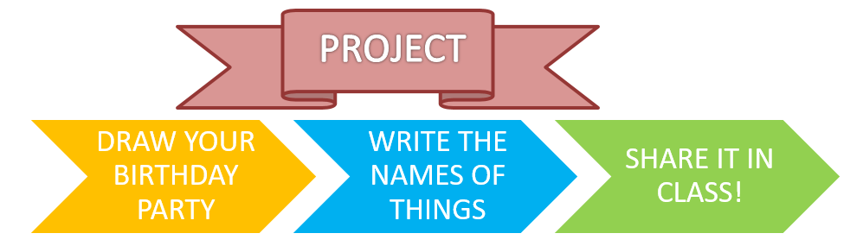
FOR EXAMPLE:

