Home Schooling 23
TODAY WE’RE REVIEWING UNIT 1
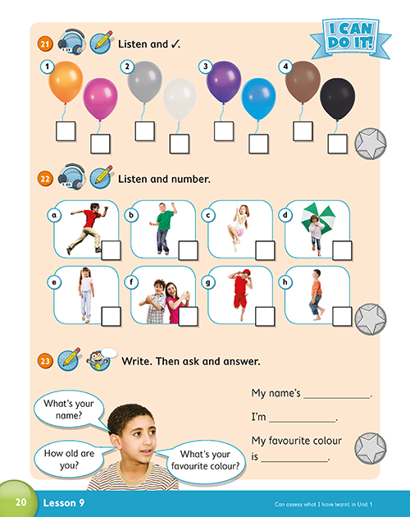

NOW GO ONLINE

NOW CLICK AND WORK ONLINE:
23A: https://forms.gle/xRQbBxdHUJ2h8sMs5
23B: https://forms.gle/fNRUQSjbBGAtGDyJ9
PLEASE PRESS “SUBMIT/SEND” AT THE END OF YOUR ONLINE WORK
POR FAVOR PRESIONAR “ENVIAR” AL FINAL DEL TRABAJO EN LINEA

