Home Schooling 26

TODAY WE’RE LEARNING TO COUNT TO TWENTY!

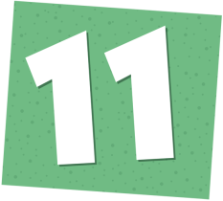 | 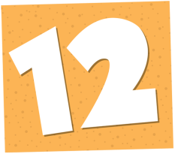 | 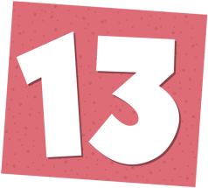 | 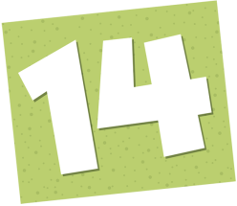
ELEVEN | TWELVE | THIRTEEN | FOURTEEN | FIFTEEN
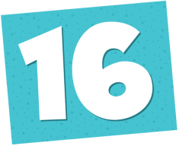 | 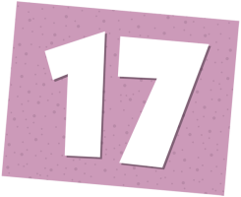 | 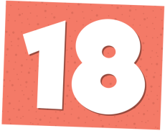
SIXTEEN | SEVENTEEN | EIGHTEEN | NINETEEN | TWENTY
PRESS CTRL AND CLICK TO LISTEN TO THE NUMBERS:

https://bit.ly/374uglz

WATCH AND SING: https://bit.ly/2UhADg3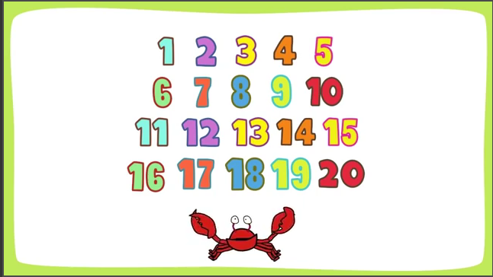
NOW CTRL+ CLICK AND WORK ONLINE:
https://forms.gle/VNwiFUFoNzynX3hv9
PLEASE PRESS “SUBMIT/SEND” AT THE END OF YOUR ONLINE WORK
POR FAVOR PRESIONAR “ENVIAR” AL FINAL DEL TRABAJO EN LINEA

