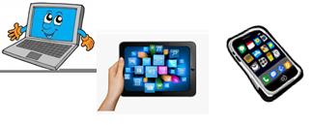
Home Schooling 27

LET’S PRACTICE SOME QUESTIONS!

Press ctrl and click to listen to the audio file:
https://bit.ly/3dFgR5I

FIRST, LISTEN AND REPEAT:
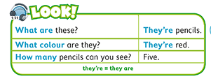

NOW, CTRL + CLICK AND WORK ONLINE:
https://forms.gle/YATQTvjJRu3tdhpB7
PLEASE PRESS “SUBMIT/SEND” AT THE END OF YOUR ONLINE WORK
POR FAVOR PRESIONAR “ENVIAR” AL FINAL DEL TRABAJO EN LINEA

