Home Schooling 28

TODAY WE’RE WORKING WITH A STORY!
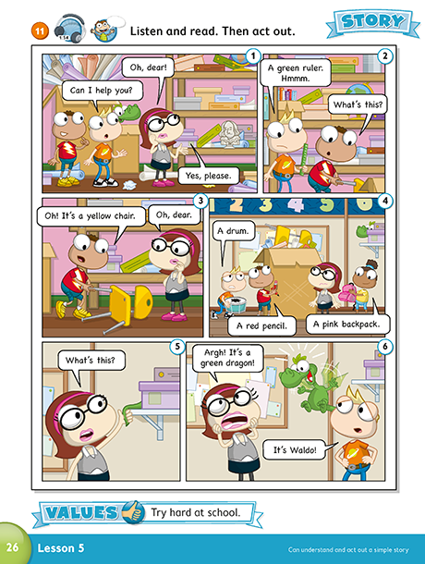
NOW GO ONLINE

CTRL+ CLICK AND WORK ONLINE:
https://forms.gle/JESVkYzzJzWfZWkbA
PLEASE PRESS “SUBMIT/SEND” AT THE END OF YOUR ONLINE WORK
POR FAVOR PRESIONAR “ENVIAR” AL FINAL DEL TRABAJO EN LINEA

