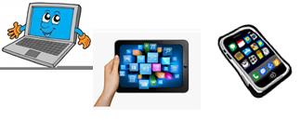
Home Schooling 29
TODAY WE’RE LEARNING ABOUT MUSICAL INSTRUMENTS!
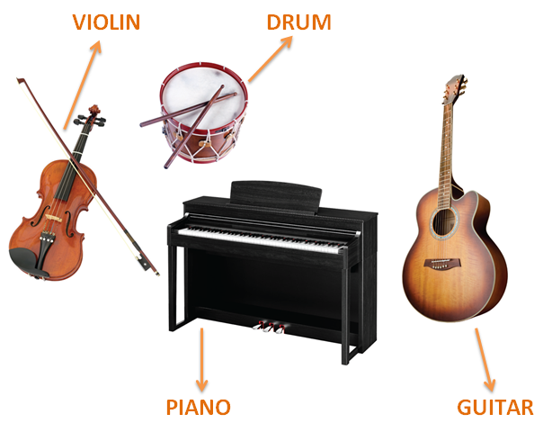
NOW GO ONLINE

CTRL+CLICK AND WORK ONLINE:
https://forms.gle/KmLbJKo7LASQW75z8
PLEASE PRESS “SUBMIT/SEND” AT THE END OF YOUR ONLINE WORK
POR FAVOR PRESIONAR “ENVIAR” AL FINAL DEL TRABAJO EN LINEA

