Home Schooling 33
TODAY WE’RE PRACTICING QUESTIONS AND FAMILY WORDS!
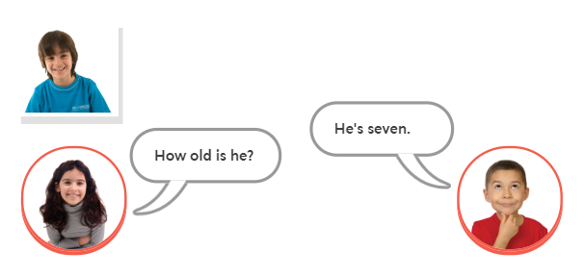
HOW OLD IS HE?
HE’S SEVEN.
NOW GO ONLINE

CTRL+CLICK AND WORK ONLINE:
https://forms.gle/jUN3UKgbqt5FXUj37
PLEASE PRESS “SUBMIT/SEND” AT THE END OF YOUR ONLINE WORK
POR FAVOR PRESIONAR “ENVIAR” AL FINAL DEL TRABAJO EN LINEA

