Home Schooling 36
TODAY WE’RE TALKING ABOUT JOBS!

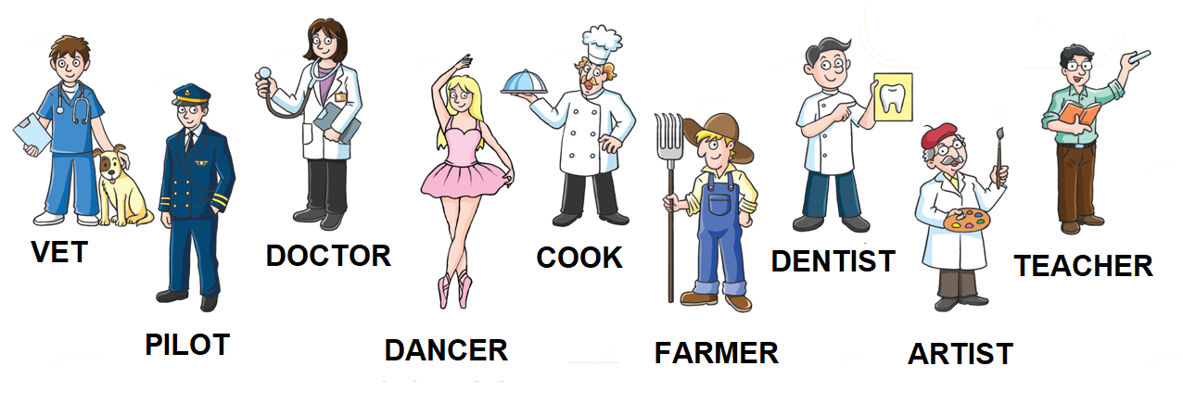
NOW GO ONLINE

CTRL+CLICK AND WORK ONLINE:
https://forms.gle/f8RDZx7cfm6WhnJA7
PLEASE PRESS “SUBMIT/SEND” AT THE END OF YOUR ONLINE WORK
POR FAVOR PRESIONAR “ENVIAR” AL FINAL DEL TRABAJO EN LINEA

