 ***Home Schooling 38***

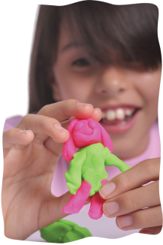**WELCOME BACK!**

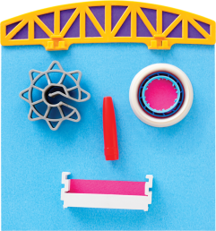TODAY WE’RE TALKING ABOUT **ART** AND **FAMILIES**!

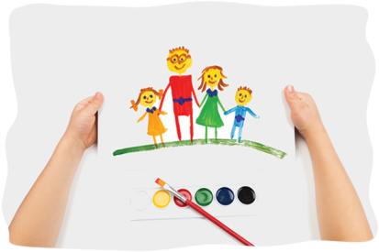

NOW GO ONLINE

**CTRL+CLICK AND WORK ONLINE:**

**<https://forms.gle/DPTqWEqTH5Vh3bMz9>**

|  |
| --- |
| **PLEASE PRESS “SUBMIT/SEND” AT THE END OF YOUR ONLINE WORK**  **POR FAVOR PRESIONAR “ENVIAR” AL FINAL DEL TRABAJO EN LINEA** |



|  |  |  |
| --- | --- | --- |
| 1. **CHOOSE:** | | |
| **https://lh5.googleusercontent.com/xlV-jZr2N83dDgknw-B7FKa53fsmzZNfLpT7wM2N9jXndwM9SbT15btSe3MPRiwHSK3cZC6OlRA-QffdySwpeRokUIoQJW1Tr7K33ellp7qFGftNd8aJoM6Vk1ic4CClgHaxwl-XQA0**  **COLLAGE** | **https://lh5.googleusercontent.com/Q_IPNGGb1OyUTuVzrTrcZpeebF6gcs6nKP67GWh-blU_lHLMOGSDR4T7b1CyzxhJf9uI44cGVi-GE-JcccywJ1-KUUxc-vMdLKDP-un5fhtaaEotoev-0dbZbSnHY8faRlKrdppDDnA**  **DRAWING** | **https://lh6.googleusercontent.com/0e6ObmIpcpxtdfL2l-FjFCOlzsdB6JmC1QAJrx8wYB_L_pGjN4SWhJjqYYOVoqQlHbgNzNIUEw3xCih1leYN2r-F8hY3PiVxTPYwLgJwOgwYjvVf_ZbDV080v1espzWMdSe30uPvD0A**  **PAINTING** |
| 1. **SHOW YOUR FAMILY** | | |
| Family Collage - DIY - Artsy Craftsy Mom | Stick Family Drawing Royalty Free Vector Image | 2nd grade Family Portraits (step by step lesson) (With images ... |
| 1. **SHARE IT AT OUR ZOOM CLASS** | | |
| Branded virtual background in Zoom – Excell Design & Marketing | | |

