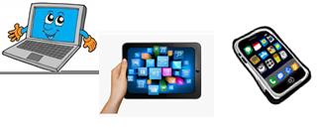
Home Schooling 40
TODAY WE’RE STARTING UNIT 4 AND LEARNING BODY PARTS
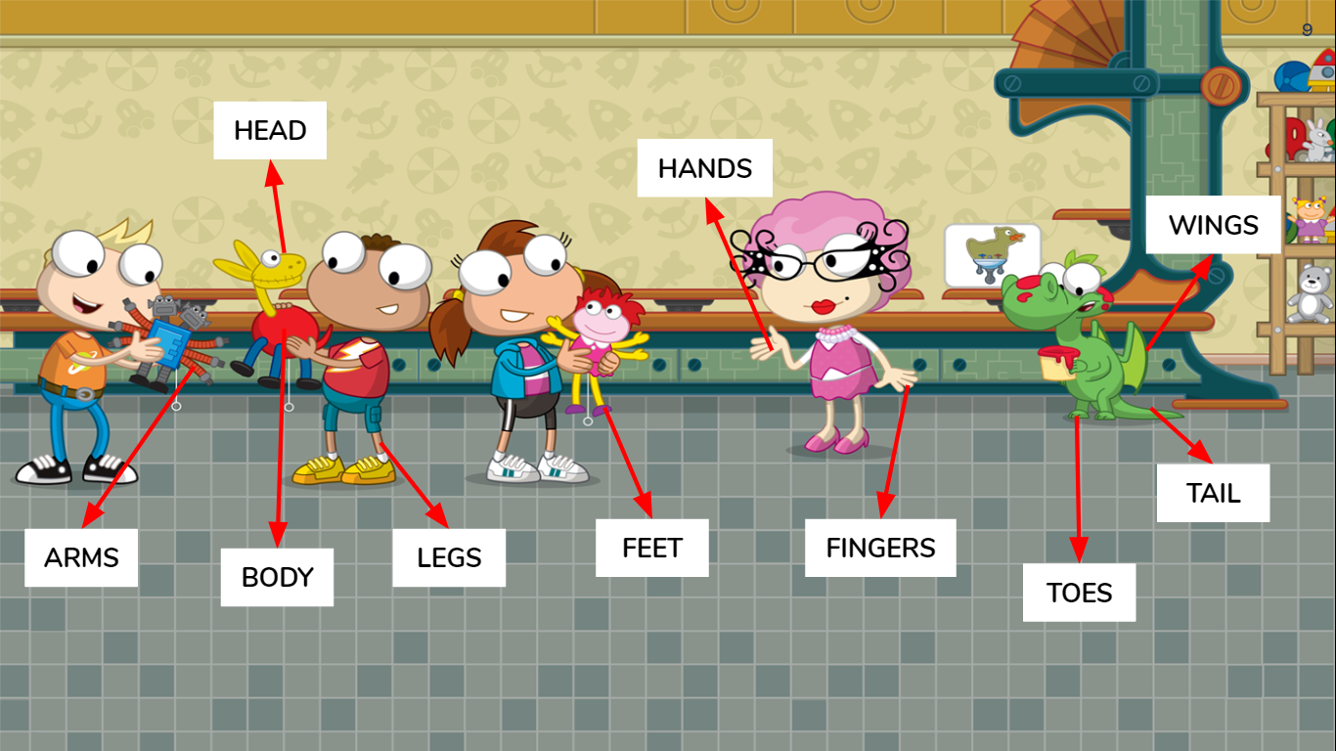

NOW GO ONLINE

CTRL+CLICK AND WORK ONLINE:
https://forms.gle/cbj8Kzz4aLgVm9Ug9
PLEASE PRESS “SUBMIT/SEND” AT THE END OF YOUR ONLINE WORK
POR FAVOR PRESIONAR “ENVIAR” AL FINAL DEL TRABAJO EN LINEA

