Home Schooling 41
TODAY WE’RE LEARNING SENTENCES WITH ‘HAVE GOT’

FIRST, LISTEN AND REPEAT:
Press ctrl and click to listen to the audio file:
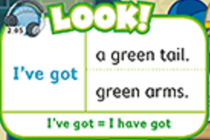
https://bit.ly/30y1Leb

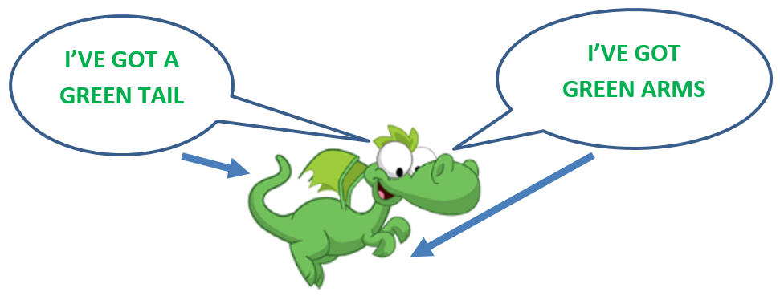

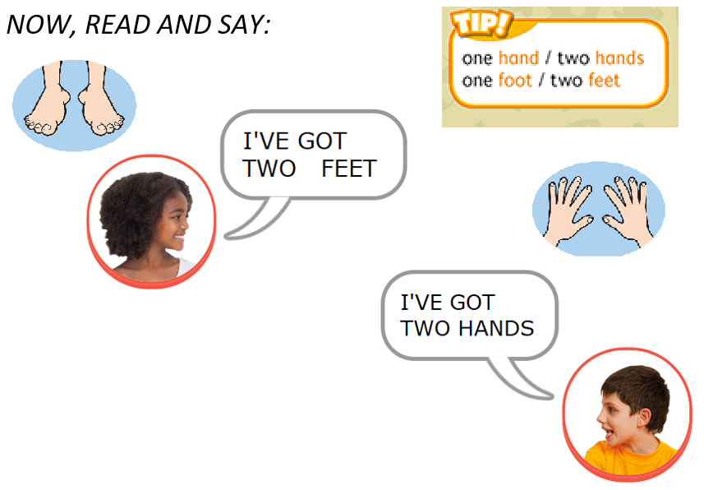
NOW GO ONLINE

CTRL+CLICK AND WORK ONLINE:
https://forms.gle/yP6SNSx7xfmEyR6H8
PLEASE PRESS “SUBMIT/SEND” AT THE END OF YOUR ONLINE WORK
POR FAVOR PRESIONAR “ENVIAR” AL FINAL DEL TRABAJO EN LINEA

