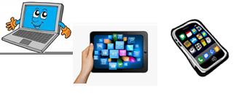
Home Schooling 42
TODAY WE’RE PRACTICING BODY PARTS WITH MONSTERS UNIVERSITY!
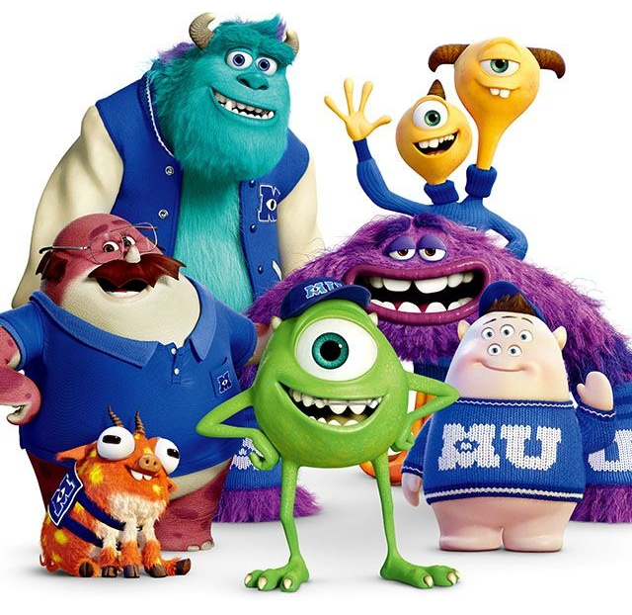
NOW GO ONLINE

CTRL+CLICK AND WORK ONLINE:
https://forms.gle/pwcuU1puQTmZMDj38
PLEASE PRESS “SUBMIT/SEND” AT THE END OF YOUR ONLINE WORK
POR FAVOR PRESIONAR “ENVIAR” AL FINAL DEL TRABAJO EN LINEA

