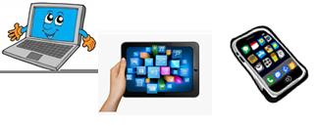
Home Schooling 44
TODAY WE’RE LEARNING CLOTHES VOCABULARY
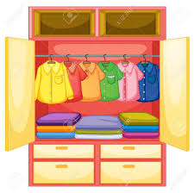
NOW GO ONLINE

CTRL+CLICK AND WORK ONLINE:
https://forms.gle/ShuJ6Tm8TemQoJn98
PLEASE PRESS “SUBMIT/SEND” AT THE END OF YOUR ONLINE WORK
POR FAVOR PRESIONAR “ENVIAR” AL FINAL DEL TRABAJO EN LINEA

