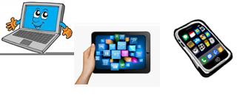
Home Schooling 46
TODAY WE’RE LEARNING HOW TO KEEP CLEAN!

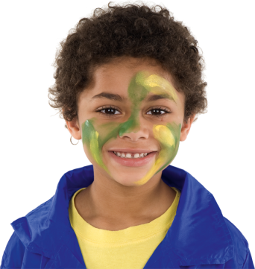 | 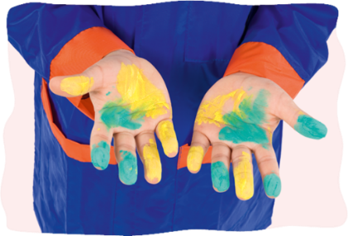
A DIRTY FACE | DIRTY HANDS
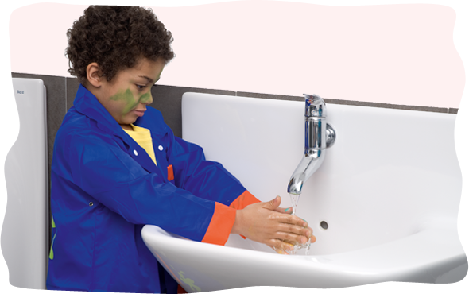
WASH YOUR HANDS! | CLEAN HANDS
NOW GO ONLINE

CTRL+CLICK AND WORK ONLINE:
https://forms.gle/cRTDKqQmJ6pFyRxKA
PLEASE PRESS “SUBMIT/SEND” AT THE END OF YOUR ONLINE WORK
POR FAVOR PRESIONAR “ENVIAR” AL FINAL DEL TRABAJO EN LINEA

