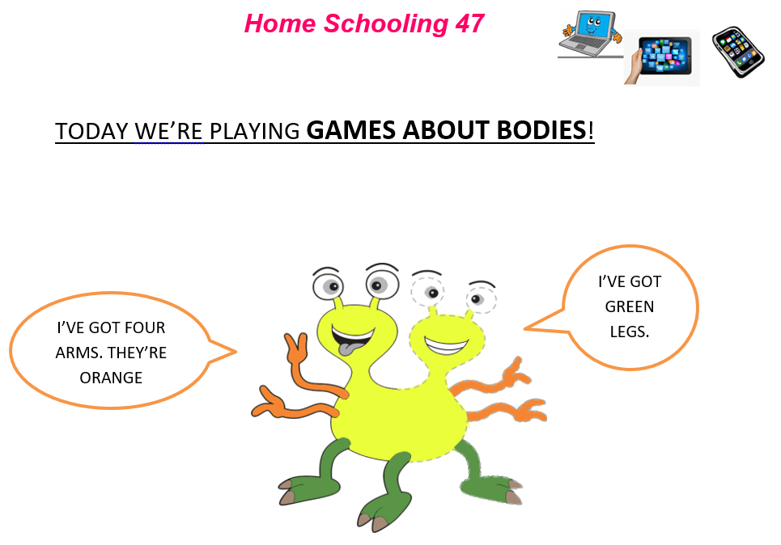
NOW GO ONLINE

CTRL+CLICK AND WORK ONLINE:
https://forms.gle/JQhJXhTUj6P4UgqS6
PLEASE PRESS “SUBMIT/SEND” AT THE END OF YOUR ONLINE WORK
POR FAVOR PRESIONAR “ENVIAR” AL FINAL DEL TRABAJO EN LINEA
1st FORM PROJECT

- WORK ON PAPER, CHOOSE:

COLLAGE | 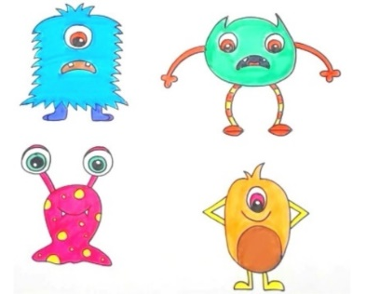  DRAWING
- CREATE YOUR MONSTER FAMILY
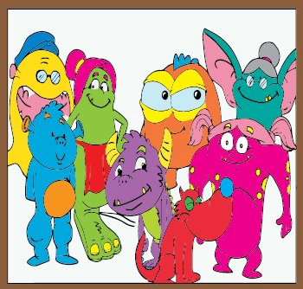

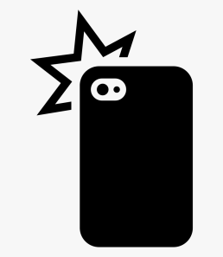
- TAKE A PHOTO

- UPLOAD IT TO JAMBOARD
INSTRUCTIONS TO UPLOAD YOUR PICTURE:

CTRL+CLICK ON YOUR GROUP’S LINK
(HACER CTRL+CLICK EN EL VINCULO DE TU GRUPO)

BOYS – 1ST “A” (LAST NAME A – I): https://bit.ly/3loZ5Ii
BOYS – 1ST “A” (LAST NAME L – R): https://bit.ly/32FDlzc
GIRLS – 1ST “B” (LAST NAME A – G): https://bit.ly/31HCaAm
GIRLS – 1ST “B” (LAST NAME I – W): https://bit.ly/3gJF9wa

FIRST SCREEN (PRIMER PANTALLA)

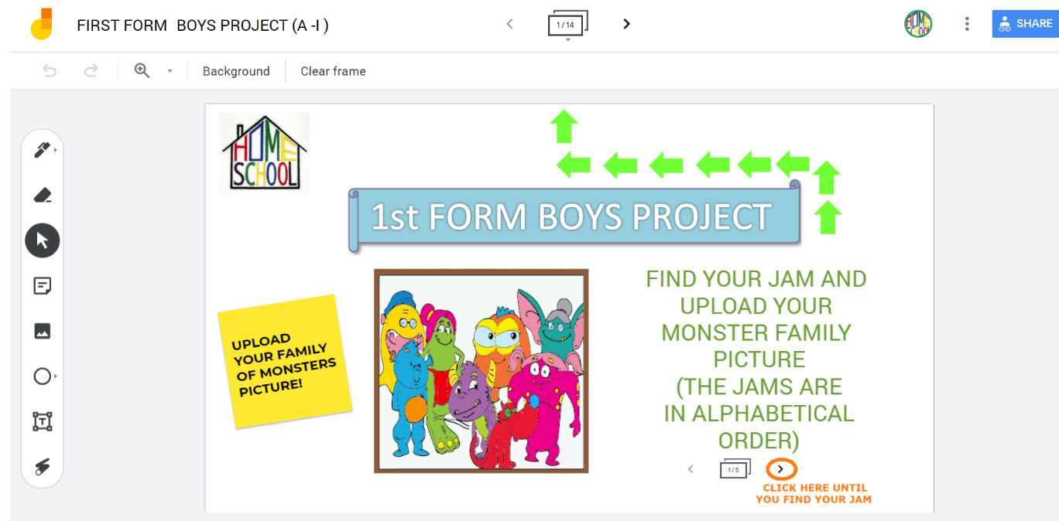

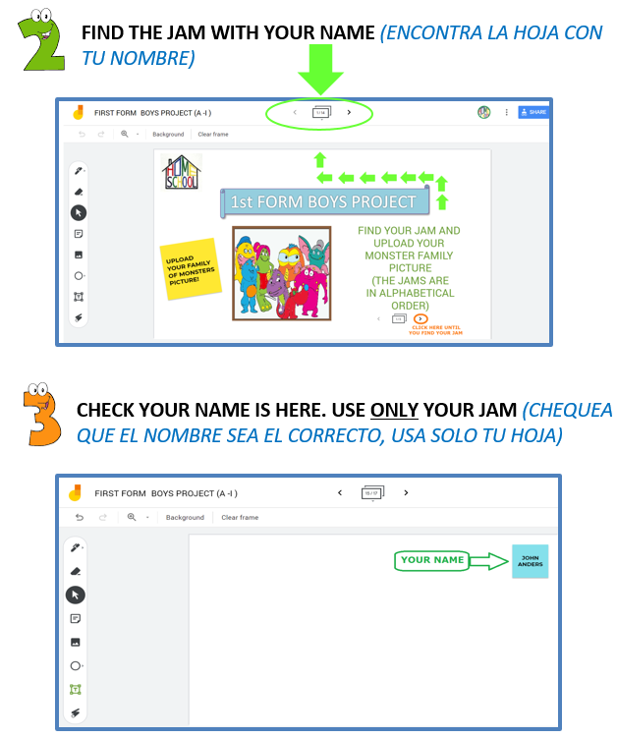
UPLOAD YOUR PICTURE (SUBI LA FOTO DE TU TRABAJO)

