Home Schooling 48
TODAY WE’RE PRACTICING UNIT 4!
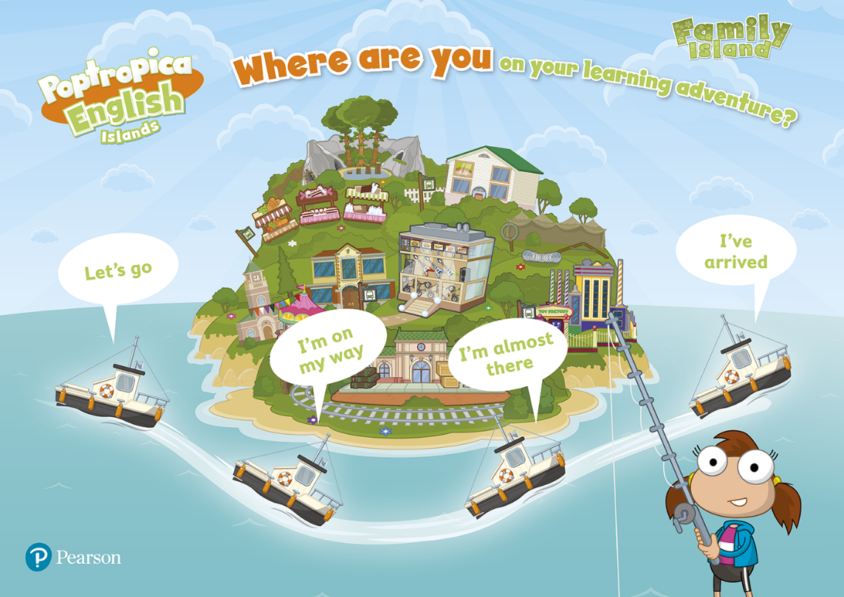
NOW GO ONLINE

CTRL+CLICK AND WORK ONLINE:
https://forms.gle/nLBKzi9aUS7QTZYz9
PLEASE PRESS “SUBMIT/SEND” AT THE END OF YOUR ONLINE WORK
POR FAVOR PRESIONAR “ENVIAR” AL FINAL DEL TRABAJO EN LINEA

