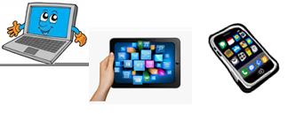
Home Schooling 50

TODAY WE’RE READING “THE KING’S NEW CLOTHES”!
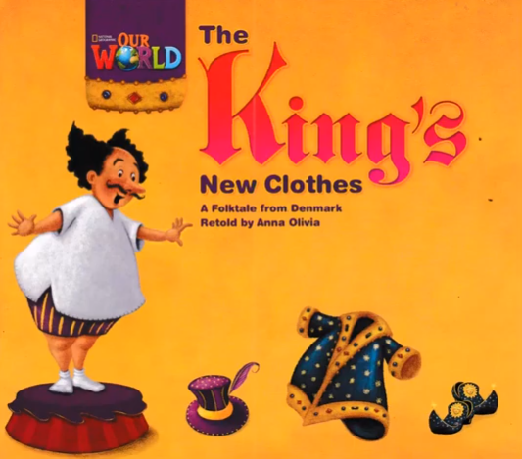
NOW GO ONLINE

CTRL+CLICK AND WORK ONLINE:
https://forms.gle/b2hBpktJ9rbLY39A8
PLEASE PRESS “SUBMIT/SEND” AT THE END OF YOUR ONLINE WORK
POR FAVOR PRESIONAR “ENVIAR” AL FINAL DEL TRABAJO EN LINEA

