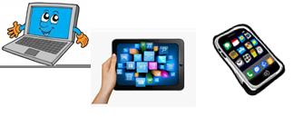
Home Schooling 52
TODAY WE’RE STARTING UNIT 5!
PETS

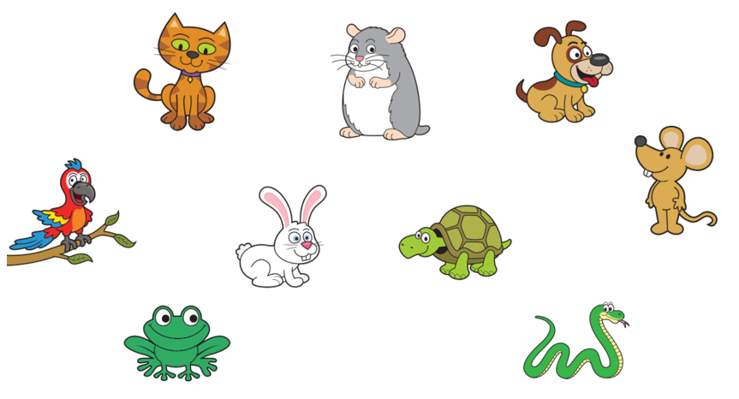
NOW GO ONLINE

CTRL+CLICK AND WORK ONLINE:
https://forms.gle/s2kaRz8GBsvjwfMc8
PLEASE PRESS “SUBMIT/SEND” AT THE END OF YOUR ONLINE WORK
POR FAVOR PRESIONAR “ENVIAR” AL FINAL DEL TRABAJO EN LINEA

