Home Schooling 53
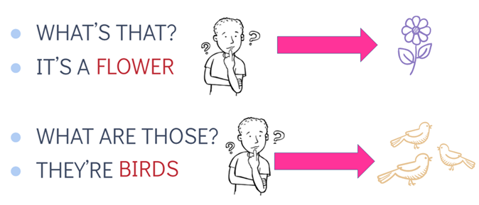
TODAY WE’RE ASKING QUESTIONS!
NOW GO ONLINE

CTRL+CLICK AND WORK ONLINE:
https://forms.gle/nvzpg3C4DtU19KCa9
PLEASE PRESS “SUBMIT/SEND” AT THE END OF YOUR ONLINE WORK
POR FAVOR PRESIONAR “ENVIAR” AL FINAL DEL TRABAJO EN LINEA

