Home Schooling 56
TODAY WE’RE PRACTICING ADJECTIVES!
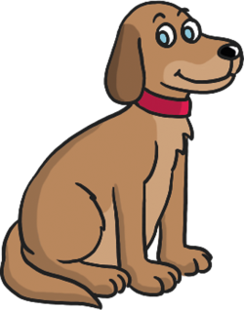  BIG | 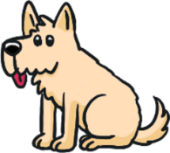  SMALL | 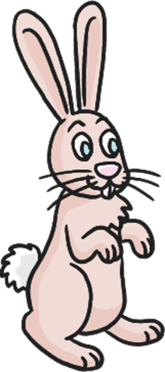 TALL
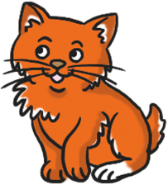  YOUNG | 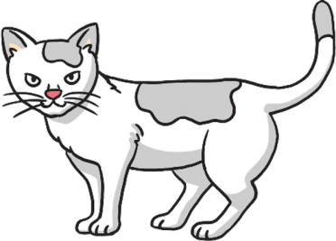  OLD | 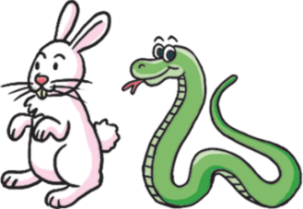  SHORT
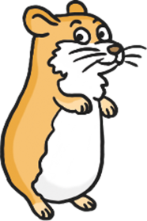  THIN | 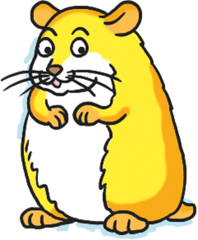  FAT | 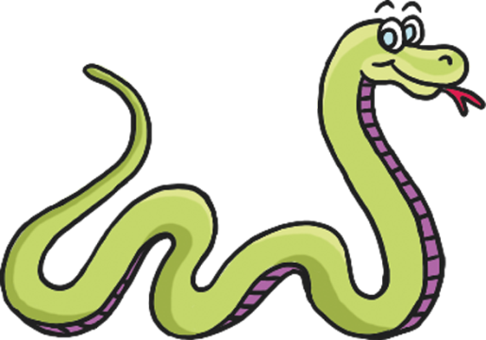  LONG

NOW GO ONLINE

CTRL+CLICK AND WORK ONLINE:
https://forms.gle/CA8TM1aVNgZ2ztbo6
PLEASE PRESS “SUBMIT/SEND” AT THE END OF YOUR ONLINE WORK
POR FAVOR PRESIONAR “ENVIAR” AL FINAL DEL TRABAJO EN LINEA

