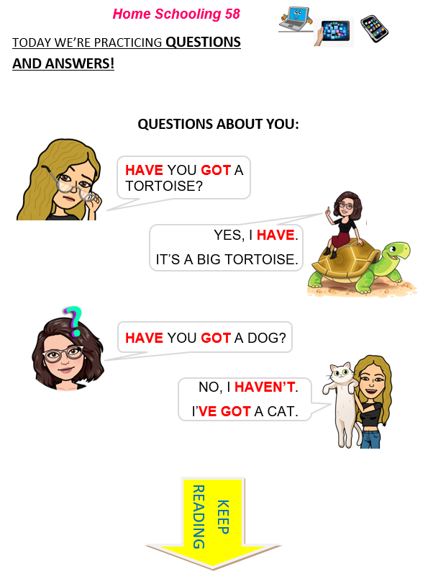
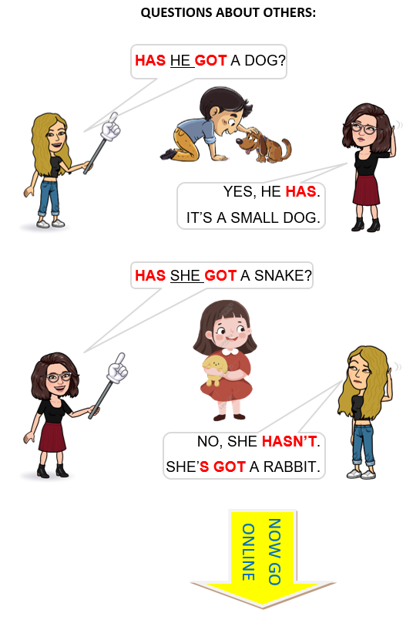

CTRL+CLICK AND WORK ONLINE:
https://forms.gle/GBfzz1RaPa4tU1QN7
PLEASE PRESS “SUBMIT/SEND” AT THE END OF YOUR ONLINE WORK
POR FAVOR PRESIONAR “ENVIAR” AL FINAL DEL TRABAJO EN LINEA

