Home Schooling 59
TODAY WE’RE PRACTICING TALKING ABOUT ANIMALS!
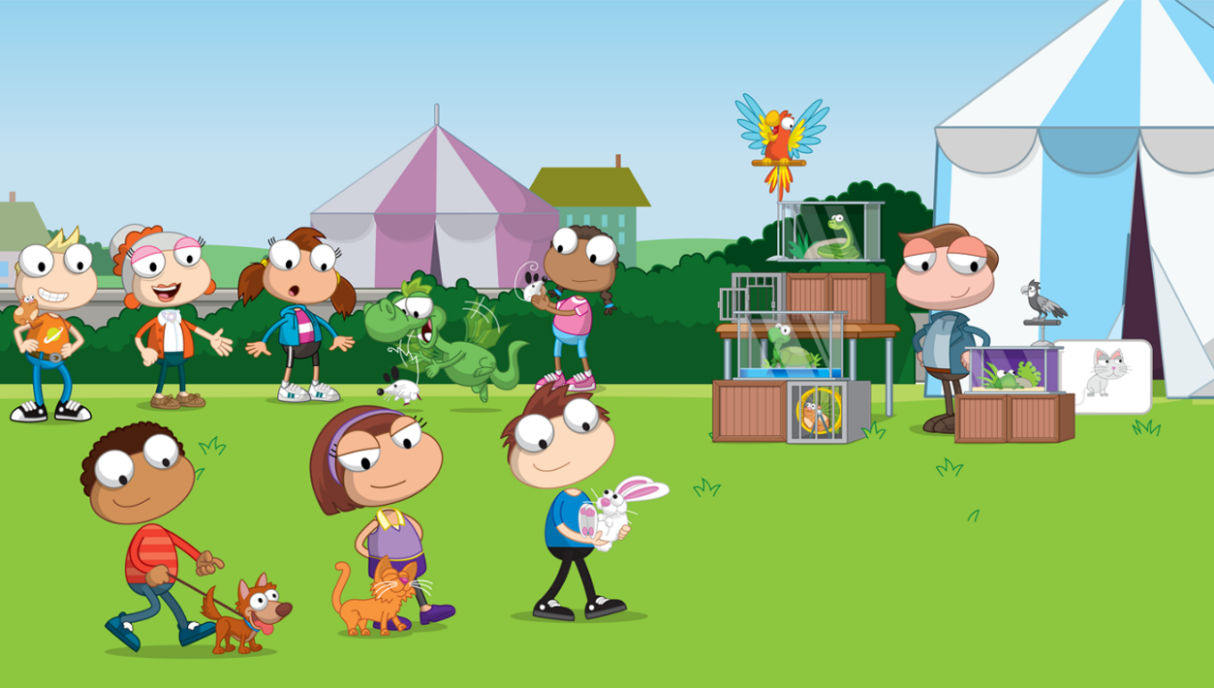
NOW GO ONLINE

CTRL+CLICK AND WORK ONLINE:
https://forms.gle/AUwbB2uNyRbcuiLd6
PLEASE PRESS “SUBMIT/SEND” AT THE END OF YOUR ONLINE WORK
POR FAVOR PRESIONAR “ENVIAR” AL FINAL DEL TRABAJO EN LINEA

