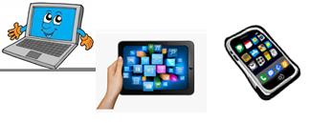
Home Schooling 65

TODAY WE’RE LEARNING ABOUT OBJECTS IN THE HOUSE!

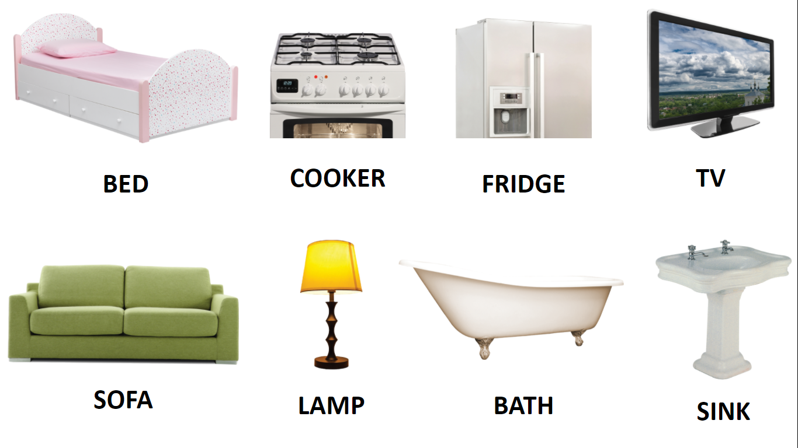

NOW GO ONLINE

CTRL+CLICK AND WORK ONLINE:
https://forms.gle/H6vHFu63LZbnYeAz5
PLEASE PRESS “SUBMIT/SEND” AT THE END OF YOUR ONLINE WORK
POR FAVOR PRESIONAR “ENVIAR” AL FINAL DEL TRABAJO EN LINEA

