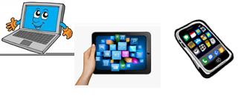
Home Schooling 66

TODAY WE’RE PRACTICING OBJECTS IN THE HOUSE!
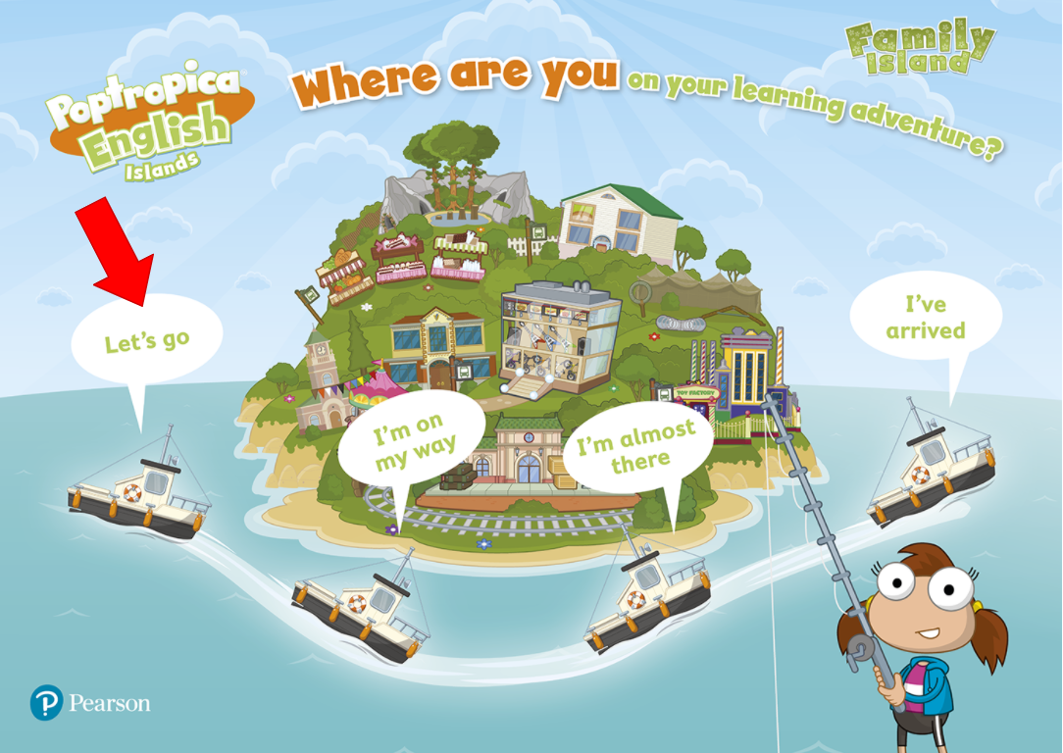
NOW GO ONLINE

CTRL+CLICK AND WORK ONLINE:
https://forms.gle/TD1gWUmecEyPNvLFA
PLEASE PRESS “SUBMIT/SEND” AT THE END OF YOUR ONLINE WORK
POR FAVOR PRESIONAR “ENVIAR” AL FINAL DEL TRABAJO EN LINEA

