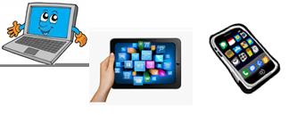
Home Schooling 67
TODAY WE’RE LEARNING ABOUT IN, ON AND UNDER
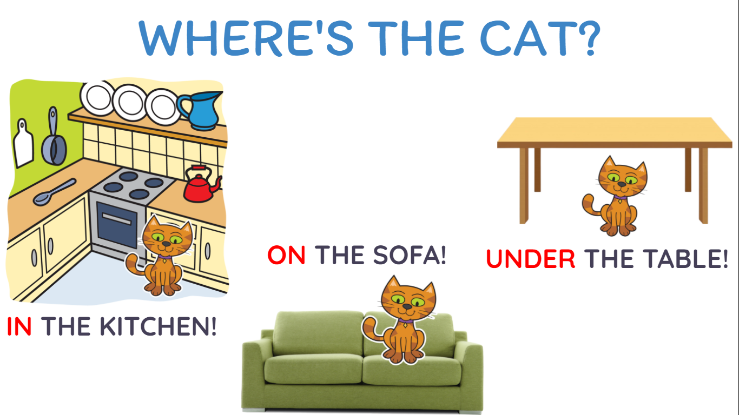
NOW GO ONLINE

CTRL+CLICK AND WORK ONLINE:
https://forms.gle/ppgKQ8X8w7ZmRSpV7
PLEASE PRESS “SUBMIT/SEND” AT THE END OF YOUR ONLINE WORK
POR FAVOR PRESIONAR “ENVIAR” AL FINAL DEL TRABAJO EN LINEA

