Home Schooling 68
TODAY WE’RE PRACTICING UNIT 6!
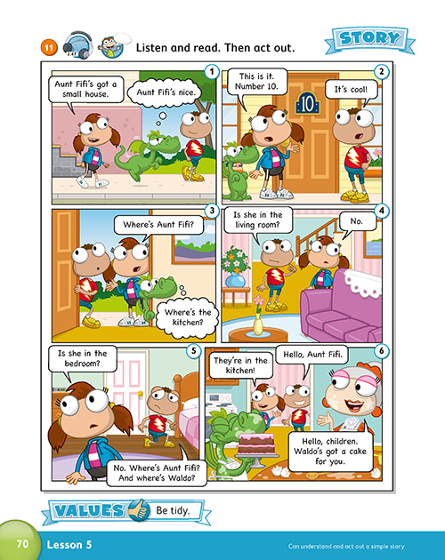
NOW GO ONLINE

CTRL+CLICK AND WORK ONLINE:
https://forms.gle/56jUiDDinmP41u8v8
PLEASE PRESS “SUBMIT/SEND” AT THE END OF YOUR ONLINE WORK
POR FAVOR PRESIONAR “ENVIAR” AL FINAL DEL TRABAJO EN LINEA

