Home Schooling 69
TODAY WE’RE LEARNING ABOUT FOOD!
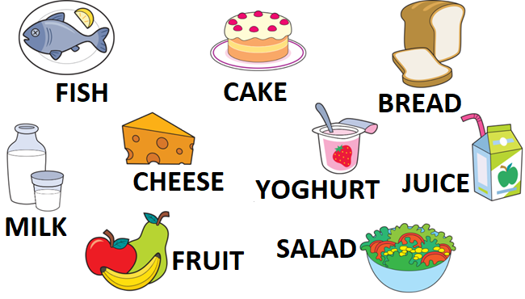
NOW GO ONLINE

CTRL+CLICK AND WORK ONLINE:
https://forms.gle/GrpYfiKWJA1zpM1Z7
PLEASE PRESS “SUBMIT/SEND” AT THE END OF YOUR ONLINE WORK
POR FAVOR PRESIONAR “ENVIAR” AL FINAL DEL TRABAJO EN LINEA

