Home Schooling 70
TODAY WE’RE TALKING ABOUT THE FOOD WE LIKE AND DON’T LIKE!
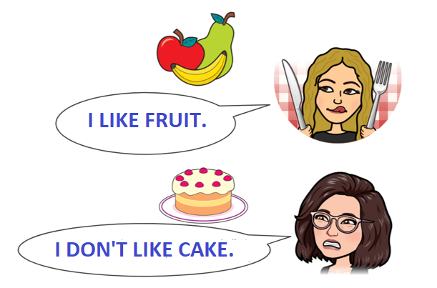
NOW GO ONLINE

CTRL+CLICK AND WORK ONLINE:
https://forms.gle/qaSUefhDjhbF2zwu9
PLEASE PRESS “SUBMIT/SEND” AT THE END OF YOUR ONLINE WORK
POR FAVOR PRESIONAR “ENVIAR” AL FINAL DEL TRABAJO EN LINEA

