Home Schooling 71
TODAY WE’RE PRACTICING UNITS 6 AND 7!
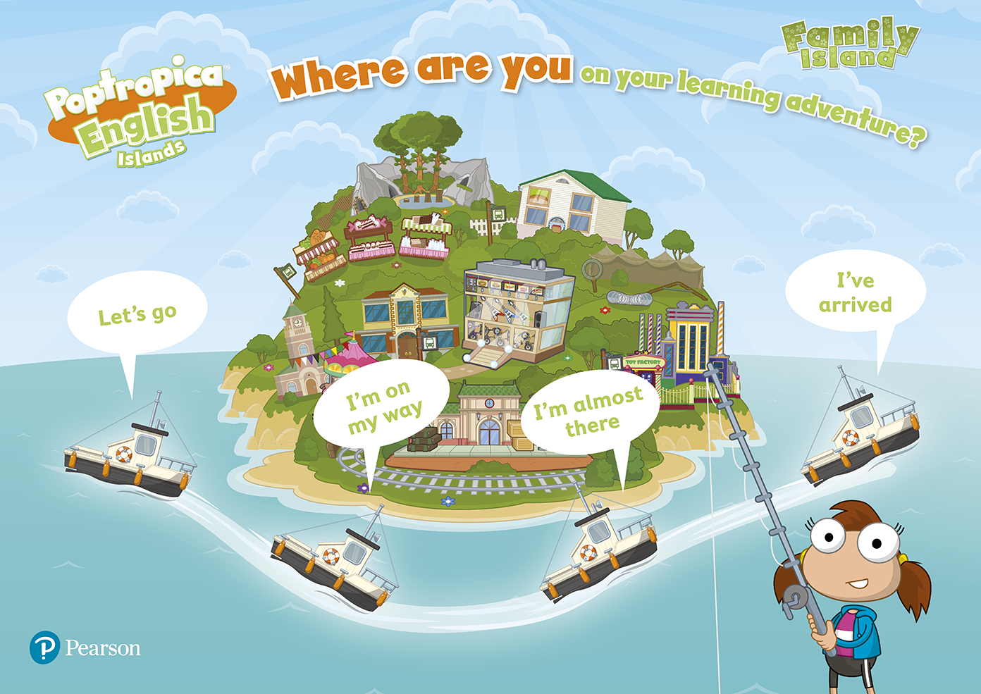
NOW GO ONLINE

CTRL+CLICK AND WORK ONLINE:
https://forms.gle/78ASJeddw7nVE8KcA
PLEASE PRESS “SUBMIT/SEND” AT THE END OF YOUR ONLINE WORK
POR FAVOR PRESIONAR “ENVIAR” AL FINAL DEL TRABAJO EN LINEA

