Name:… Surname: …
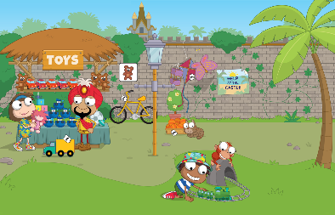
Home Schooling 11 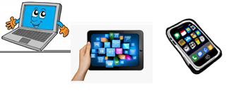
Hello!
Today we're learning to ask and answer questions about what things are.
OPEN YOUR PUPIL’S BOOK ON PAGE 13

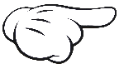

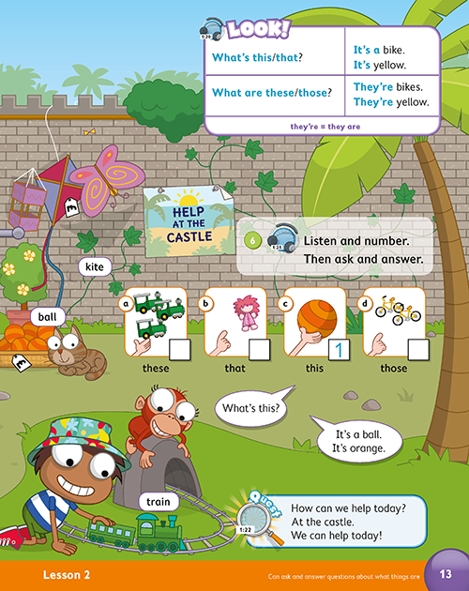

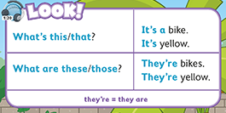
1 LOOK, LISTEN AND SAY

Press ctrl and click to listen to the audio file:
https://bit.ly/34jdmOK
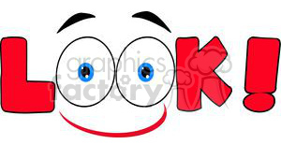

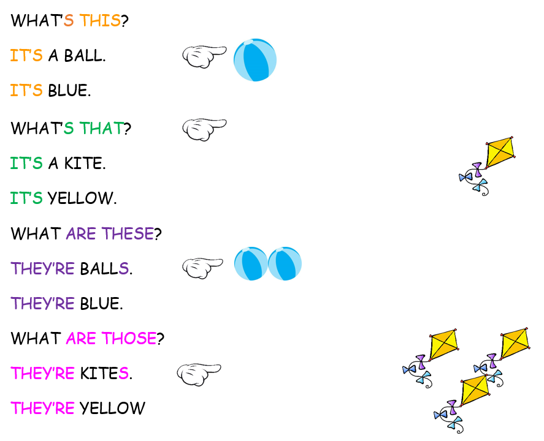

Press ctrl and click to listen to the audio file:
https://bit.ly/2wonadE
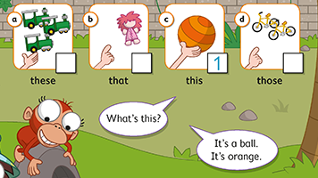
2 LISTEN AND NUMBER
…
…
…

3. LOOK AND MATCH. FILL IN THE CHART
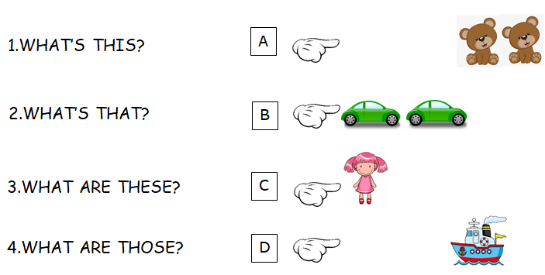
1 | C | 2 | … | 3 | … | 4 | …

4. NOW, ANSWER THE QUESTIONS ABOVE.
FOR EXAMPLE:

- IT’S A DOLL. IT’S PINK.

2. …

3. …

4. …

5. WRITE THE QUESTION OR THE ANSWER.

Example: WHAT’S THAT?  IT’S A … |  |  | 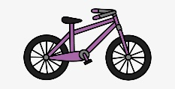
- WHAT … … ?  THEY’RE LORRIES. |  | 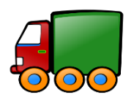  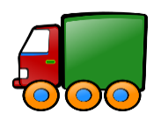
- WHAT ARE THOSE?  … |  |  | 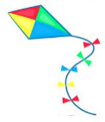
- … ?  IT’S A TRAIN. |  |  | 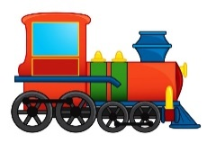
- WHAT ARE THESE?  … |  | 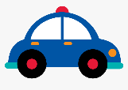  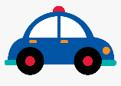
- … ?
IT’S A …

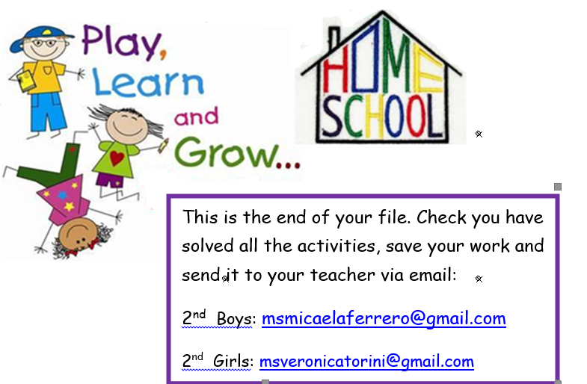
NOW GO ONLINE

NOW CLICK AND WORK ONLINE:
https://forms.gle/fQYQb84xxQTtYs3t9
PLEASE PRESS “SUBMIT/SEND” AT THE END OF YOUR ONLINE WORK
POR FAVOR PRESIONAR “ENVIAR” AL FINAL DEL TRABAJO EN LINEA

