Name:…
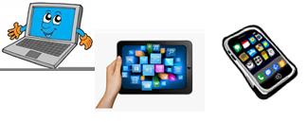
Surname: …

Home Schooling 12

- LOOK. THEN READ AND CHOOSE THE CORRECT WORD. WRITE.

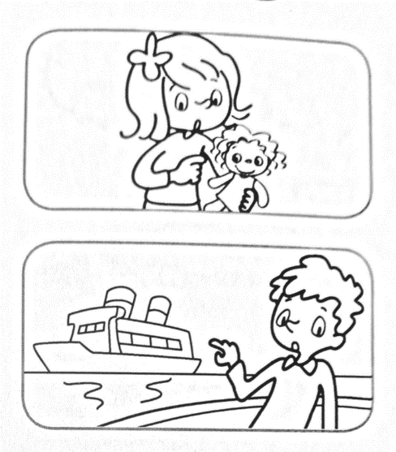
- (WHAT’S / WHAT ARE) WHAT’S THIS?

IT’S A DOLL (BALL / DOLL / TEDDY BEAR).

- (WHAT’S / WHAT ARE) … THAT?

IT’S A … (BOAT / BIKE / TRAIN).

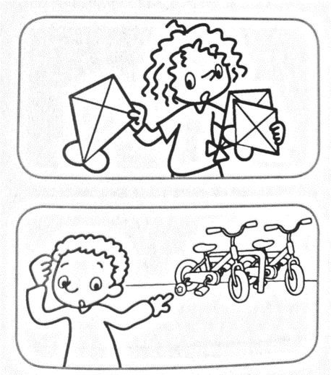
- (WHAT’S / WHAT ARE) … THESE?

THEY’RE … (KITE / KITES / LORRIES).

- (WHAT’S / WHAT ARE) … THOSE?

THEY’RE … (BIKES / BIKE / BALL).

- WRITE QUESTIONS AND ANSWERS.

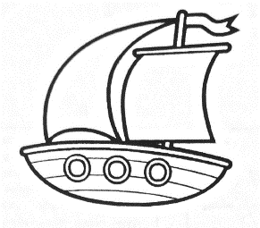
A.
WHAT’S THIS?
IT’S A BOAT.

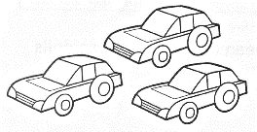
B. …
…

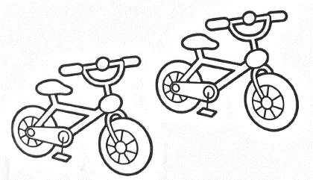
C.
…
…

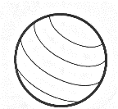
D. …
…

- READ THE ANSWERS AND WRITE THE QUESTIONS.
1. What are these? They’re books.
How many books are there? There are three.
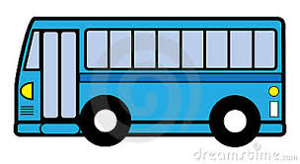
2. … ? It’s a bus.
… ? There’s one.

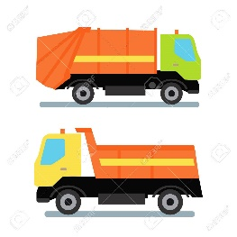
3. … ? They’re lorries.
… ? There are two.

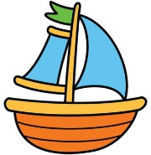
- … ? It’s a boat.
… ? There’s one.

https://www.educaplay.com/learning-resources/5333716-toys.html

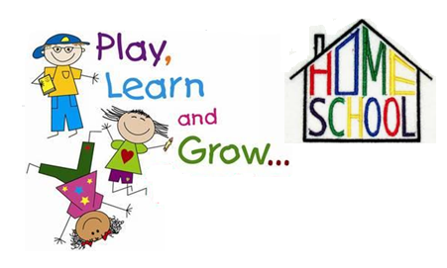
This is the end of your file. Check you have solved all the activities, save your work and send it to your teacher via email:
2nd Boys: msmicaelaferrero@gmail.com
2nd Girls: msveronicatorini@gmail.com

