Name:…
Surname: …

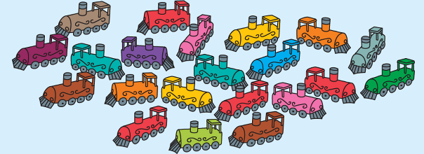
Home Schooling 13
HELLO!
TODAY WE ARE LEARNING TO ASK QUESTIONS USING ‘HOW MANY’

OPEN YOUR PUPIL’S BOOK ON PAGE 15
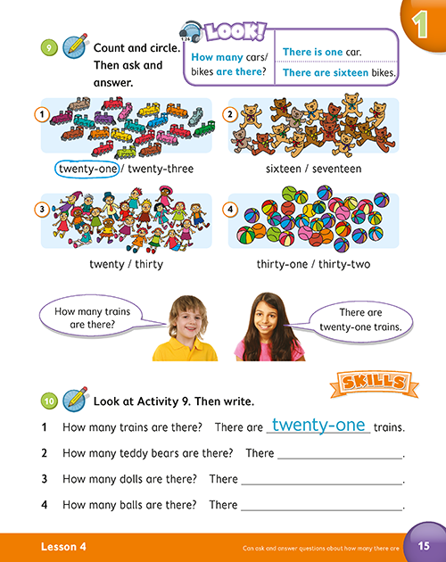

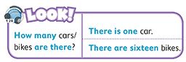
1 LOOK, LISTEN AND SAY
Press ctrl and click to listen to the audio file:
https://bit.ly/2xYzvWn
2 COUNT AND SELECT THE CORRECT ANSWER.
EXAMPLE:
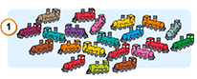 | TWENTY-ONE x  TWENTY-THREE . . .
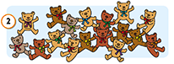 | SIXTEEN . . .  SEVENTEEN . . .
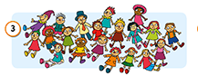 | TWENTY . . .  THIRTY . . .
THIRTY-ONE . . .
THIRTY-TWO . . .

3 ANSWER THE QUESTIONS
EXAMPLE:
- HOW MANY TRAINS ARE THERE?
THERE ARE TWENTY-ONE TRAINS.

- HOW MANY TEDDY BEARS ARE THERE?
THERE ...

- HOW MANY DOLLS ARE THERE?
THERE ...
- HOW MANY BALLS ARE THERE?
THERE ...
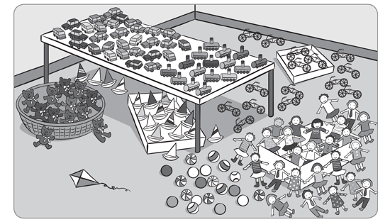
4 LOOK AND COUNT. THEN WRITE.
EXAMPLE:
- HOW MANY BIKES ARE THERE?
THERE ARE FIFTEEN BIKES.

- ... ... ... ARE THERE?
THERE ARE ... ...

- ... ... ... ARE THERE?
THERE ARE ... ...

- ... ... ... ARE THERE?
THERE IS ... ...

5 UNSCRAMBLE. THEN WRITE AND ANSWER.

EXAMPLE:
KITES THERE HOW ARE ? MANY
HOW MANY KITES ARE THERE?
THERE ARE SIX KITES
MANY ARE ? HOW DOLLS THERE
HOW ... ... ... ...
THERE ... ... ...

THERE TEDDY BEARS MANY ? ARE HOW
... ... ... ... ... ?
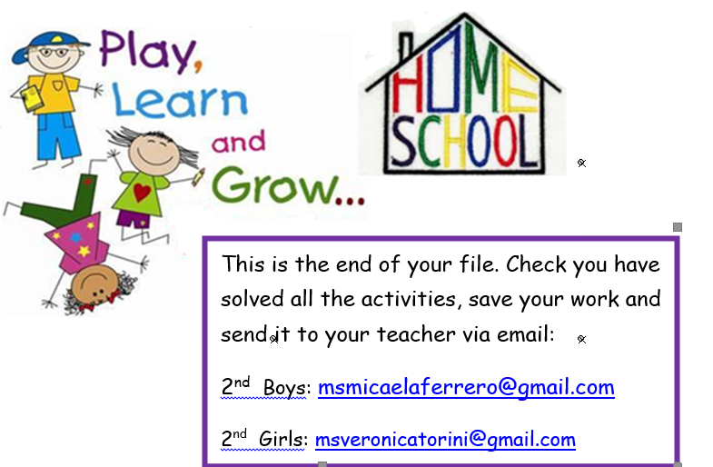
... ... ... ...
NOW GO ONLINE

CLICK AND WORK ONLINE:
https://forms.gle/ouRC6R6CAR23cCR86
PLEASE PRESS “SUBMIT/SEND” AT THE END OF YOUR ONLINE WORK
POR FAVOR PRESIONAR “ENVIAR” AL FINAL DEL TRABAJO EN LINEA

