Name:…
Surname: …
Home Schooling 14
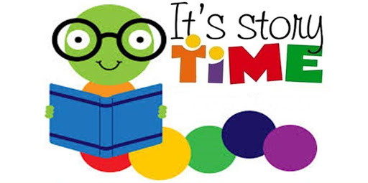

- Look at page 16 from the Pupil’s Book.
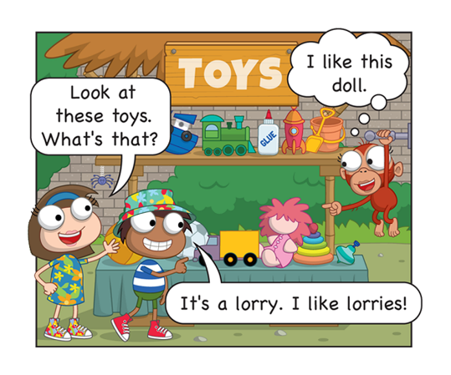
What are we learning today?
We’re reading a story about help at the castle.

Press ctrl and click to listen to the audio file:
https://bit.ly/3abWB9m

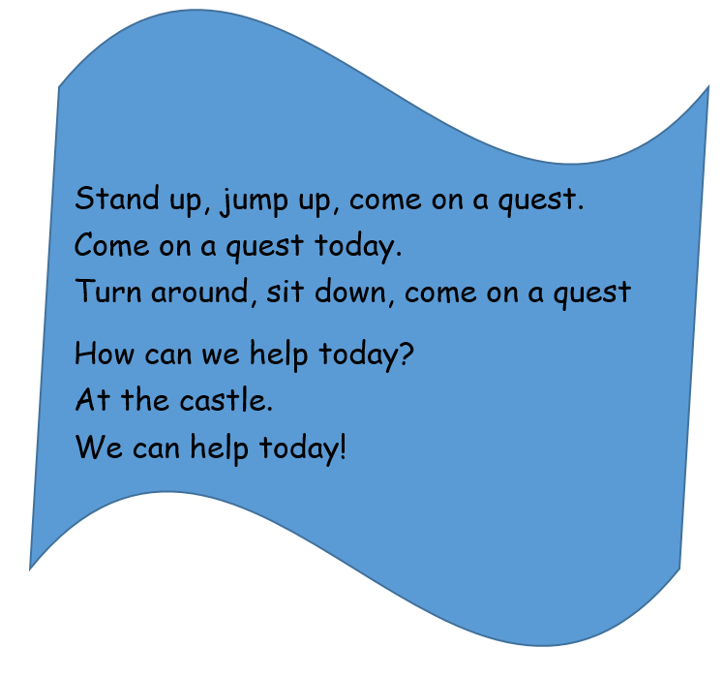
*Listen and sing the quest song.

Press ctrl and click to listen to the audio file:
https://bit.ly/34YJVC1

- Listen and read the story.

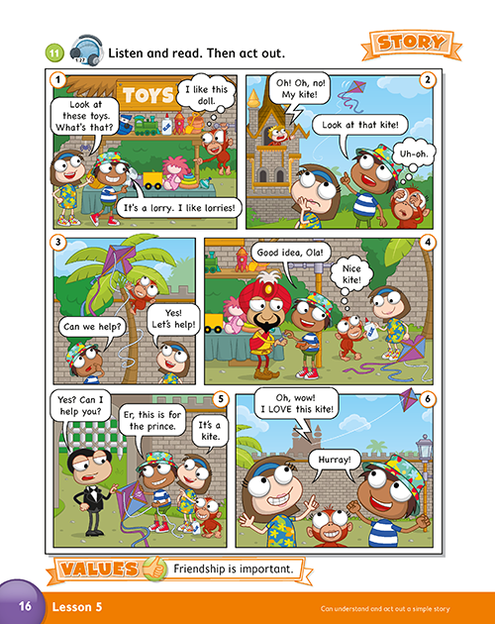
- YES or NO?

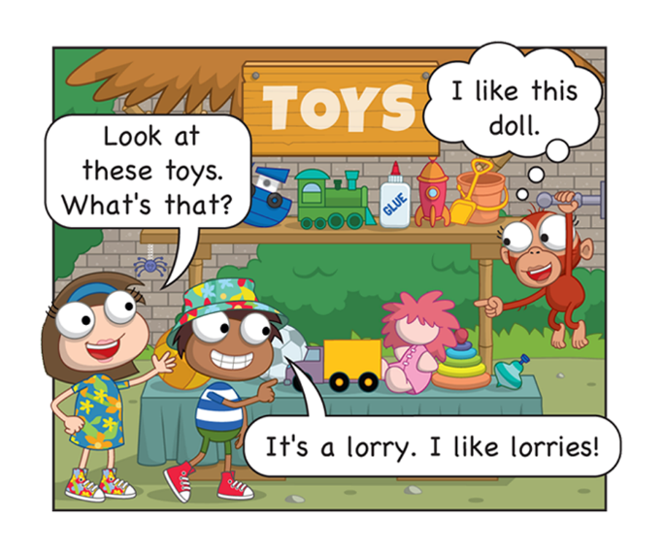 | DOES CHARLIE LIKE LORRIES?  YES
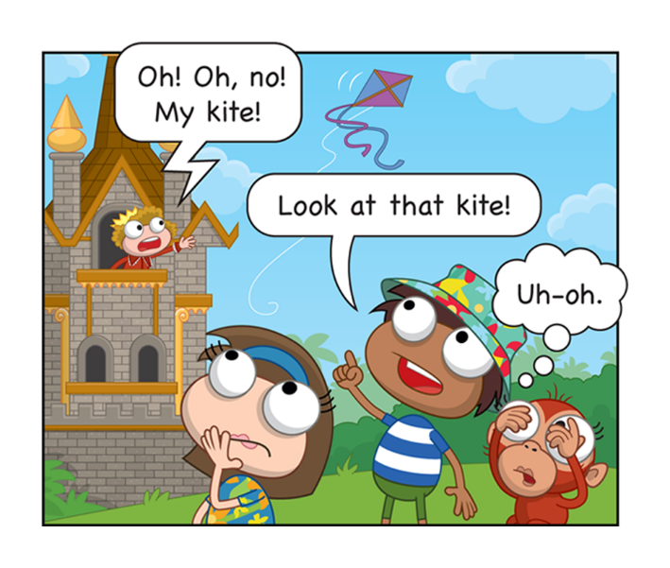 | DOES THE PRINCE LOSE THE KITE?  …
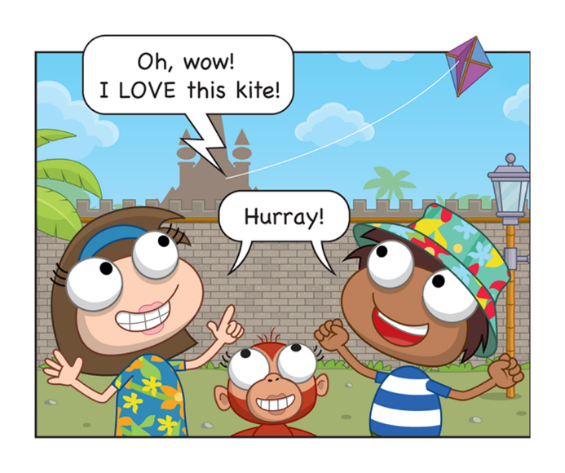 | DOES OLA LOVE THE KITE?  …

- Look and write.
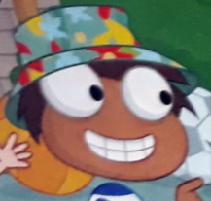  I LIKE  … | 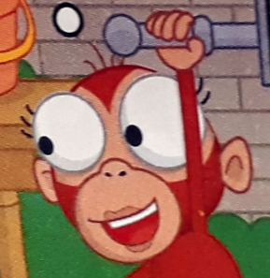  I LIKE  …
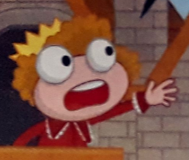  I LIKE  … | 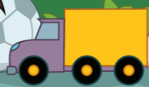  TOYS (Be careful! There is an extra toy!)  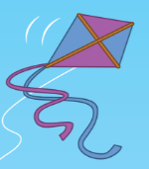  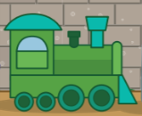

- Look and number. Can you tell the story again?

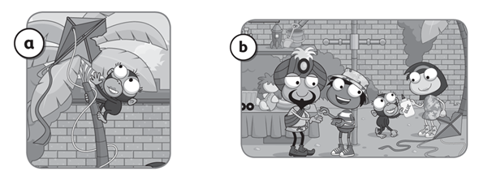
…
…

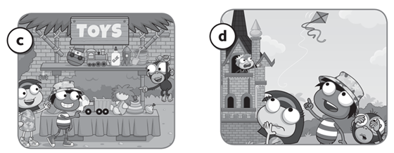
…

…

‘FRIENDSHIP IS IMPORTANT’.
- Look and x the correct picture. Then write about you.
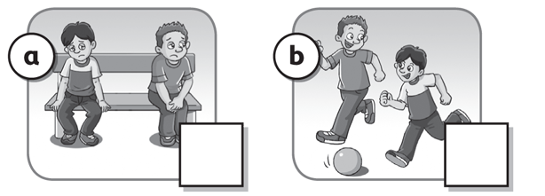  …  … | Good friends play together and share toys.
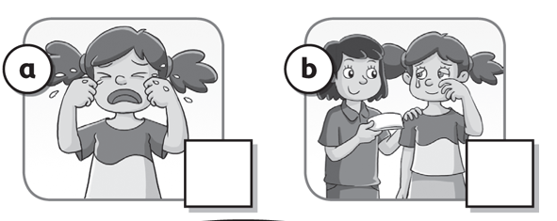  …  … | Good friends listen and help.
*Think of a good friend.
… is a good friend.

*What do you like?
We like … and … .

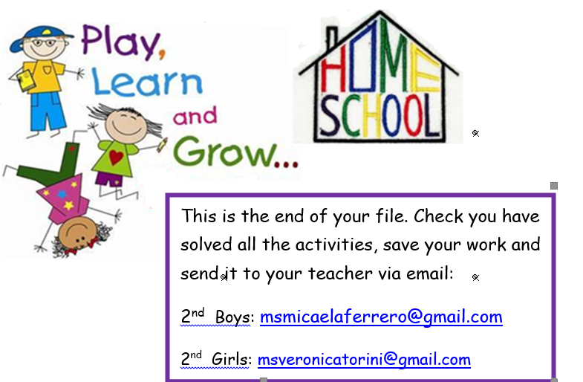

NOW CLICK AND WORK ONLINE:
A)
https://forms.gle/mCPDM1FtXsax16Jx8
B)
https://forms.gle/y6tEEo4iQVimym1F6

PLEASE PRESS “SUBMIT/SEND” AT THE END OF YOUR ONLINE WORK
POR FAVOR PRESIONAR “ENVIAR” AL FINAL DEL TRABAJO EN LINEA

